



SCHealthPlusMe Documentation

Written By: Matt Harrington

**Table of Contents**

* **Introduction to SCHealthPlusMe**
  + Build Release for Play Console……………………………………..……..page 3
  + Play Console………………………………………………………………………..page 6
  + GitHub………………………………………………………………………..….…..page 9
* **Health Journal**
  + Navigation…………………………………………………………………………..page 10
  + Icons…………………………………………………………………………………..page 12
  + Journal Layout Screen……………………………………………….………..page 13
  + SQLite Database……………………………………….………………………..page 16
  + Graphs………………………………………………………………………………..page 18
    - MPAndroidChart…………………………………..…………………..page 18
    - Tree Map………………………………………….…………….………..page 19
  + Card Views……………………………………………….……………….………..page 20
    - CardView…………………………….……………….…………………..page 20
    - Buttons……………………………………….………………….………..page 21
  + Reports…………………………………………….………………………………..page 25
* **Health Resources**
  + Selection Screen……………………………………………………...………..page 27
    - Permissions……………………………………………….…….……..page 29
  + Firebase…………………………………………………….……….……………..page 30
    - Connection…………………………………….….……….…………..page 30
    - Algorithm………………………………………….…….……………..page 31
  + Button Functionality………………………………….……………………..page 37
* **First Time Login**
  + Layout……………………………………………………………………………..page 38
  + Functionality…………………………………………………….….…………..page 39
  + Edit Profile………………………………………………….……….…………..page 41
* **Conclusion**……………………………………………………….………………………..page 42

**Introduction to SCHealthPlusMe**

SCHealthPlusMe is an android application that was created during the 2018-2019 school year at Francis Marion University through a grant provided by SCRA. The application’s purpose is to assist local low income and rural individuals find access to health resources, as well as give them the ability to track their health measurements over time.

The application was released with version 1.0 on May 1st, 2019 on the Google Play Store. All updates to SCHealthPlusMe must be contributed through that Google Play Developer Console found at: <https://play.google.com/apps/publish/>

The sign-in information for the fmu-scra account will be distributed in a different manner.

**Build Release for Play Console**

The following information is the steps for making a “release” build of the application using Android Studio. After this has been built, it may be added to the Play Console.

1. Open Android Studio.
2. Open the “build.gradle (Module: app)” file.
3. In this file, increment the “versionCode” value to one integer value larger as below would become a “4”:

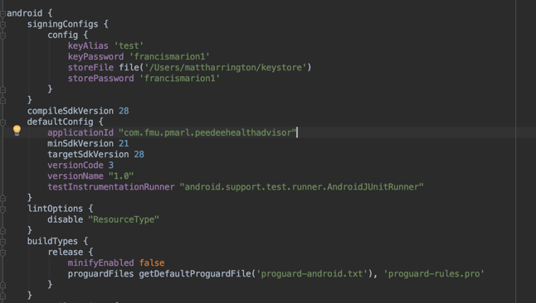

1. If you have not generated a key store path, follow these steps after clicking on the “Generate Signed Bundle / APK” dropdown in the “Build” menu as below:

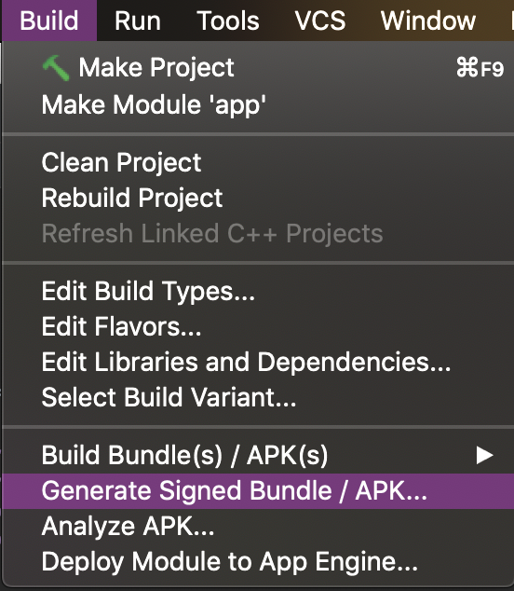

* 1. Click Next after choosing the module:

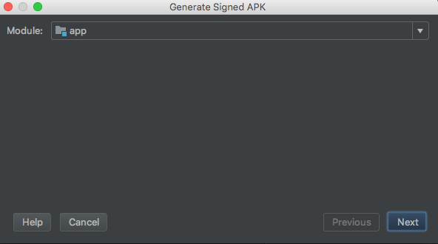

* 1. Click “Create New” to create a new Keystore:

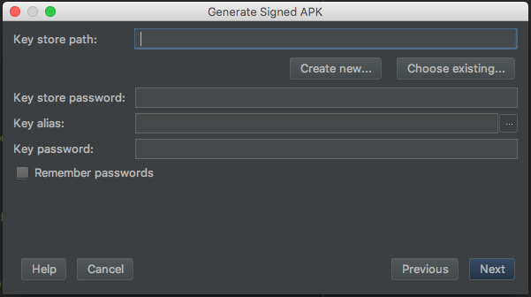

* 1. Fill out information. To keep things simple, make both passwords the same and click “OK.”

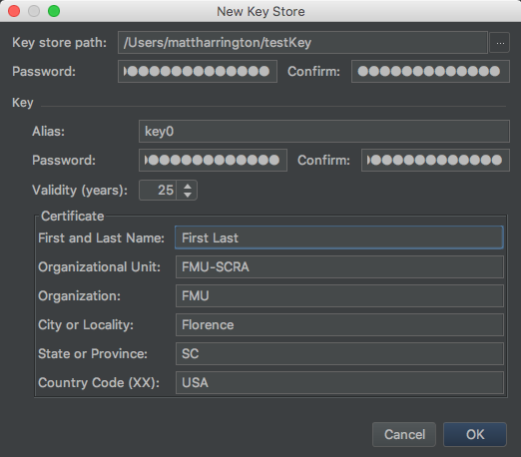

1. **Back to the main instructions**, click the “Generate Signed Bundle / APK” dropdown in the “Build” menu as below:



1. The keystore path should be pre-loaded, just enter the passwords and press “Next.”

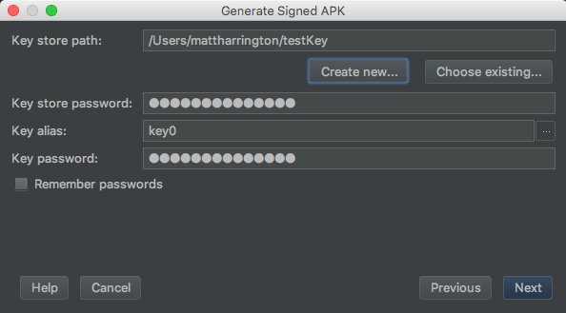

1. Choose “release” option and click on “Finish” to start the building process.

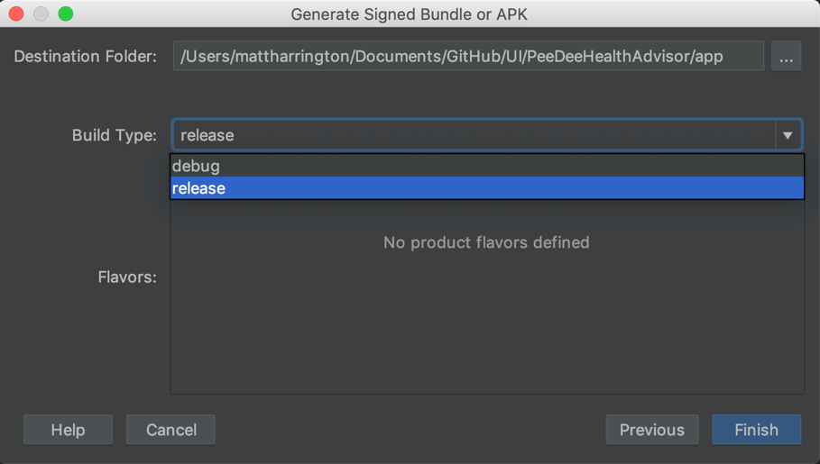

1. Once built, click on the “Locate” button given by Android Studio to get the build file from Finder or Windows Explorer.

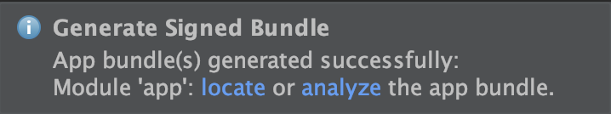

After finding the “.aab” file, you now have the correct file to upload to the Google Play Console for release.

**Play Console**

The Google Play Console is where all of the updates of the application will be loaded. The following steps take place after creating a release build (page 3).

1. To get started, log into the developer account on the Play Console.
2. Once logged in, click on the application on the selection screen.

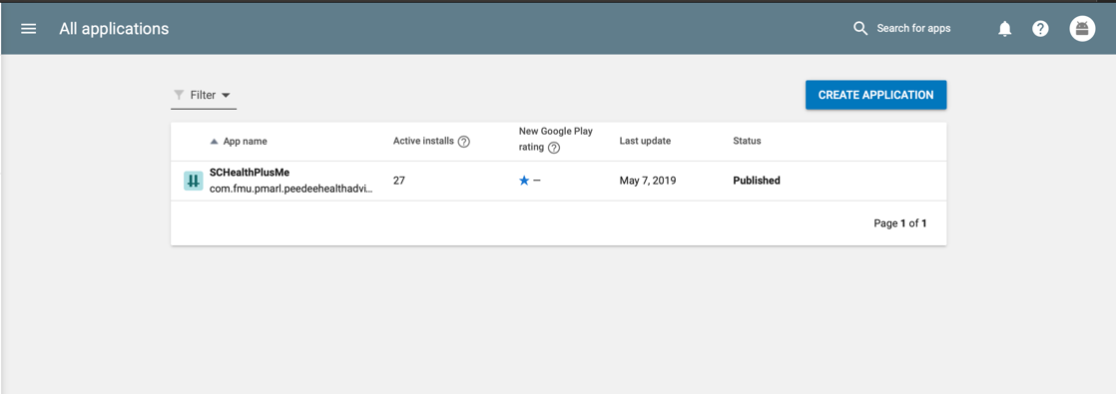

1. Here, the dashboard will display all relevant information about the application.
2. To create a release, click on the “Release Management” toggle in the left sidebar.

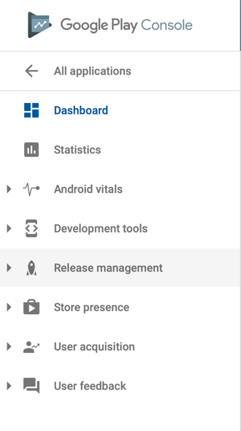

1. From the sidebar, click on “App Releases” to open the different types of releases.

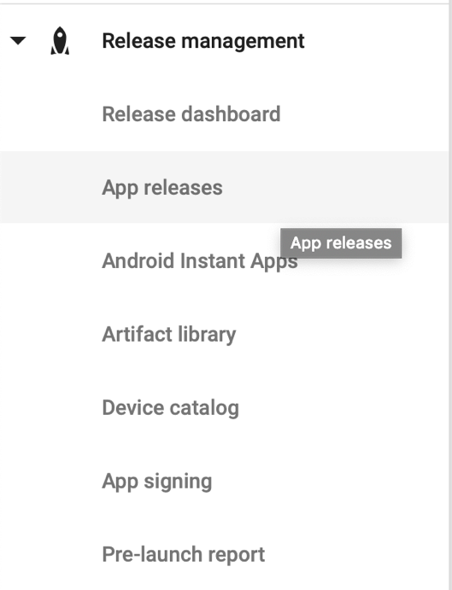

1. On the right side of the screen, find the “Internal Testing” section.

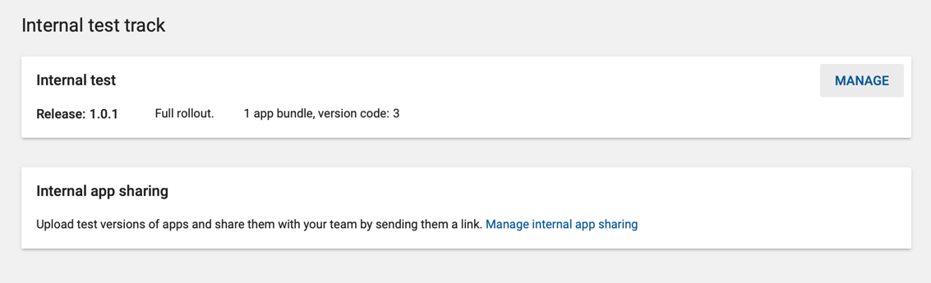

1. In this section, click on “Manage.” This will allow you to view the internal information and create a release by clicking the “Create Release” button.

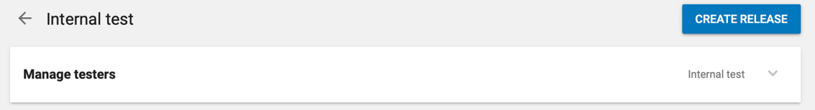

1. From the Create Release screen all information related to the release is available. Drag the “.aab” file to the “Browse Files” and wait for it to be uploaded.

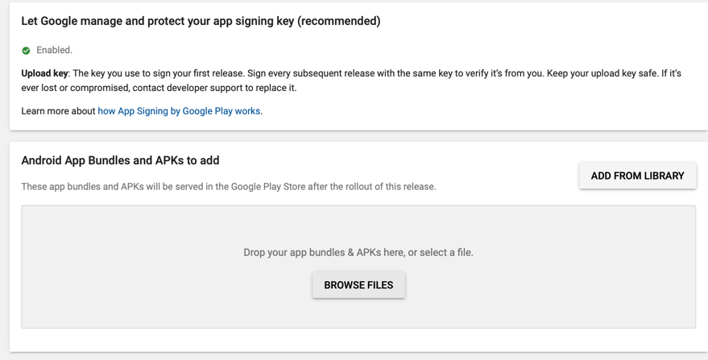

1. At the bottom of the page, fill out the release notes that will be displayed on the Play Store listing.

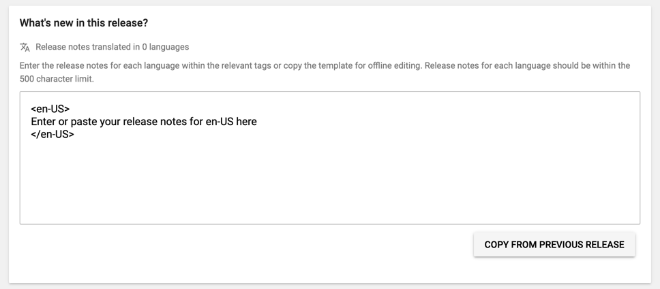

1. Click on the “Review” button, which will take you to the next screen for deploying the release.



This only releases the application to internal testers and I would do this before a public release each time. To make it public simply go to the release after it has been tested and click the “Release to Alpha” button. Then go to the Alpha Release and click the “Release to Beta” button. Then finally, go to the Beta release and click the “Release to Production” button. You are abled to copy the release notes up each time, and once it reaches “Production,” it will be released on the Play Store.

It will update periodically over the next 24 hours for different types of devices. Depending on the device, and the user’s settings, the application may update automatically, or you may have to go into the Play Store and do it manually.

Page 3 to page 8 is the cycle for updating SCHealthPlusMe. While testing the builds in Android Studio, you need to make sure to change your “build variant” to “debug” rather than “release.” This is accomplishable by clicking on the “Build Variants” tab on the left side of the screen, and switching the dropdown to “debug” as shown below:

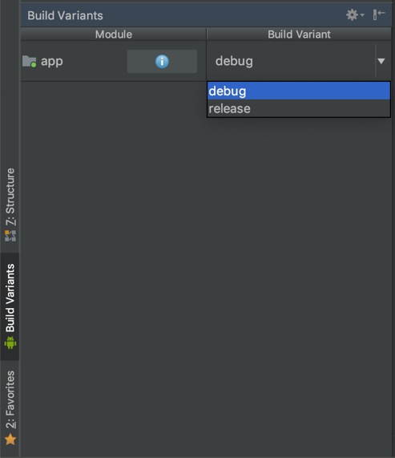

**GitHub**

The application has been managed using a GitHub repository. This document will not cover the steps of using GitHub, but it will cover the permissions, and overview information that is important for the maintainability of SCHealthPlusMe.

On the GitHub repository, there are collaborators. These collaborators should all have equal permissions. The repository itself already has the correct branch protection rules, but all new collaborators must know they must use a **“fast-forwarding”** git technique.

The master branch is protected and can only be merged with Pull Requests that need to be reviewed. After each merge, there should be a release. These releases are directly through the GitHub website and are a great backup of the source code.

Each bug fix or small change will warrant a “v1.0.x” change to the version name.

Each new feature will warrant a “v1.x.0” change to the version name.

Version 2.0.0 should not be released until a complete overhaul of the application, or a marketing strategy.

When cloning the repository, the repo will be named “UI.” The folder that “UI” resides in should be named “GitHub.”

Branches should be named “firstname/task”

The GitHub accounts must be added using the main FMU-SCRA account as collaborators. Once added, other individual accounts will be able to commit to the repository.



The Health Journal portion of SCHealthPlusMe Is where the local health measurement information is stored. The health data is stored using a local SQLite database. The data is kept secure locally on the phone, with a traditional Relational Database format.

The next few sections will detail how the Health Journal portion of the application was created, and how it is integrated together between entry and retrieval.

**Navigation**

Technical details of the application will start with the standard navigation of the application. The most basic functionality in the application is the transition between screens. Each screen is made using a corresponding “.xml” file. The “.xml” files are where the design of the application takes shape. You are able to use a drag and drop system built into Android Studio or make them programmatically. Below is an example of an xml file with the different attributes that are used on the left, with the resulting product on the right:

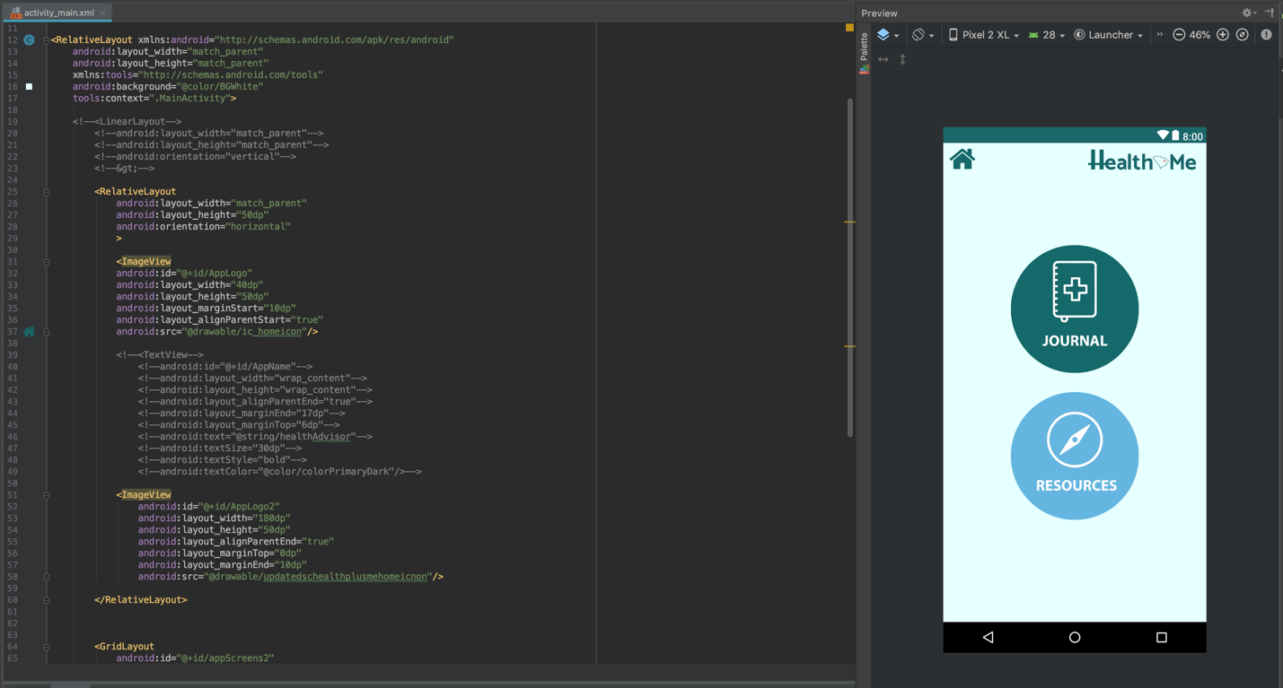

After there are buttons inserted onto the screen, with multiple screens, the best way to add functionality to a button is an “Intent.” An Intent is a built in Class in java that helps control different types of functions in Android. A prime example of an Intent is how a button press will open a new screen. Below is the code from the class referenced above (activity_main.xml) with its .java counterpart:

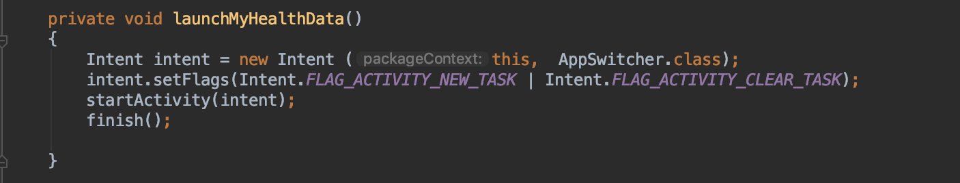

The code above will open the “Health Journal” portion of the application. You can copy and paste this code into any other method and change the “.class” reference for a new screen.

Below if the “setOnClickListener()” method that will associate the button press with the above method:

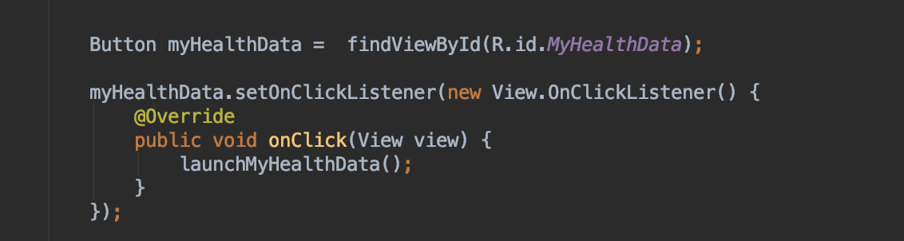

This association between visual (.xml) and functional (.java) is the entire correlation between creating an element in the xml file and associate it in the .java file.

Each screen follows the logic that is described above.

You can also do other things with the Intent class, and a “setOnClickListener()” such as allowing the phone app to be opened on a button press. Below is the code for pressing a phone icon to open the phone app with a dynamically allocated phone number which is associated with a topic discussed later known as a “Card View”:

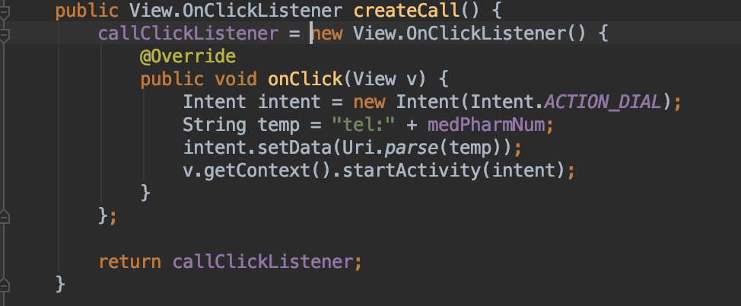

**Icons**

The Icons in the application were created in Photoshop. They will be available in multiple formats for reuse. The icons cannot simply be dragged into the application, however. First, they must be in “.png” format. After they are saved into the correct format, they need to be converted into the five different screen resolutions that Android supports. All of these different sizes range from smaller phones, such as the Galaxy S5, to a tablet such as the Google Pixel C.

There is a website that will take the “.png” and convert it into the different sizes.

1. Go to the website: <https://romannurik.github.io/AndroidAssetStudio/index.html>
2. Select the “Generic Icon Generator” selection.
3. Click on “Image” and select the correct “.png” file.
4. Set the asset size to 200dp for maximum resolution and the padding to 0dp as shown below:

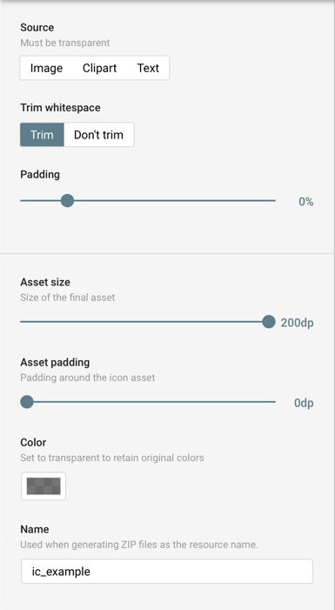

1. Change the name to “ic_whateveryoudlike” all lowercase however.
2. Download the “.zip” file, and unzip it.
3. It will have all 5 different sizes with the files inside. Take each file from inside of the files and add them to their appropiete matching folders inside of the project as shown below **(drawable-hdpi, drawable-mdpi, drawable-xhpi, drawable-xxhdpi, drawable-xxxhdpi.)**

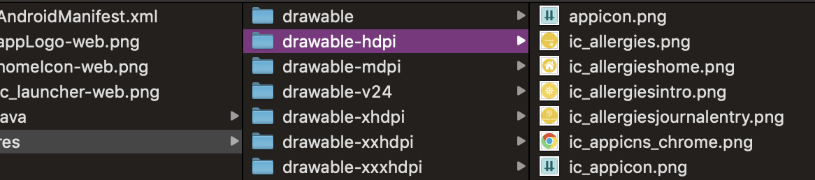

**Journal Layout Screen**

One of the most intuitive parts of the application is the Health Journal layout. The screen is plays off the circular design of the rest of the application’s roundness. It takes the circular icons, mentioned in the previous section, and puts them in a format that is similar to most phone’s grid layouts. This allows the application to be a quick learning curve, but also allows the development team to add new features by adding to the screen’s layout.

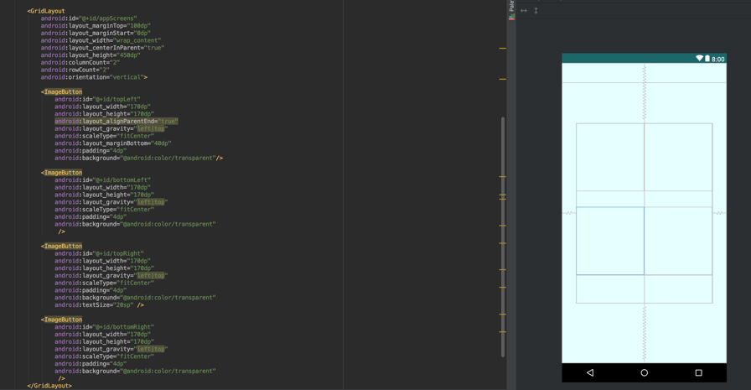The process uses two “.java” classes, with a “.xml” class. The “.xml” class is named “activity_select_data.xml” and this is where the “GridLayout” is located for the display of the different icons. The code below shows the .xml layout of the icons in the journal:

The four different components of the “GridLayout” are composed of an “ImageButton,” which is the format that the Icons are inside of SCHealthPlusMe. Each of these buttons will be assigned an icon depending on the page that is being viewed. All of the functionality for the “AdapterView” is extended from the “PagerAdapter” class that is provided for Android Development.

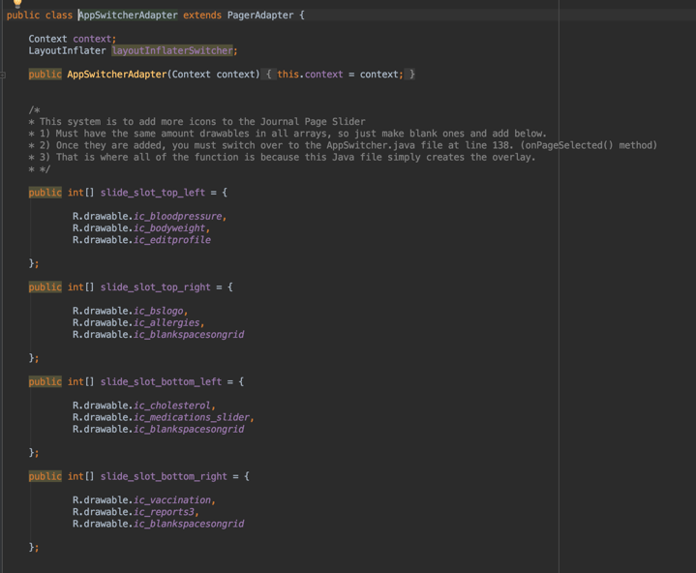The first Java class is named, “AppSwitcherAdapter.java.” This class provides the varying icons that will go into the GridLayout on each respected page. Each of the icons must be added to their appropriate array for each of the four portions of the GridLayout as shown to the right:

If there are three pages for example, each array should withhold three icons. It is very important to note that if there are black spaces, you must add the “R.drawable.ic_blackspaceongrid” icon to the array in the appropriate page slot. The elements are ordered from 0 to infinity, but 0 is the first page up until your max page amount.

The pages are determined by the PagerAdapter, which this class extends from with a couple of Overridden methods as shown below:

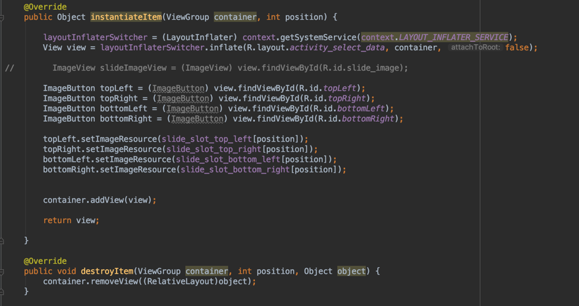

The method “instantiateItem()” is for creating the four ImageButton(s) in their different positions inside of the GridLayout. Each time the PagerAdapter recognizes that a page has changed, it will switch the instantiated buttons to the next slot in the array by calling this method and returning the new view.

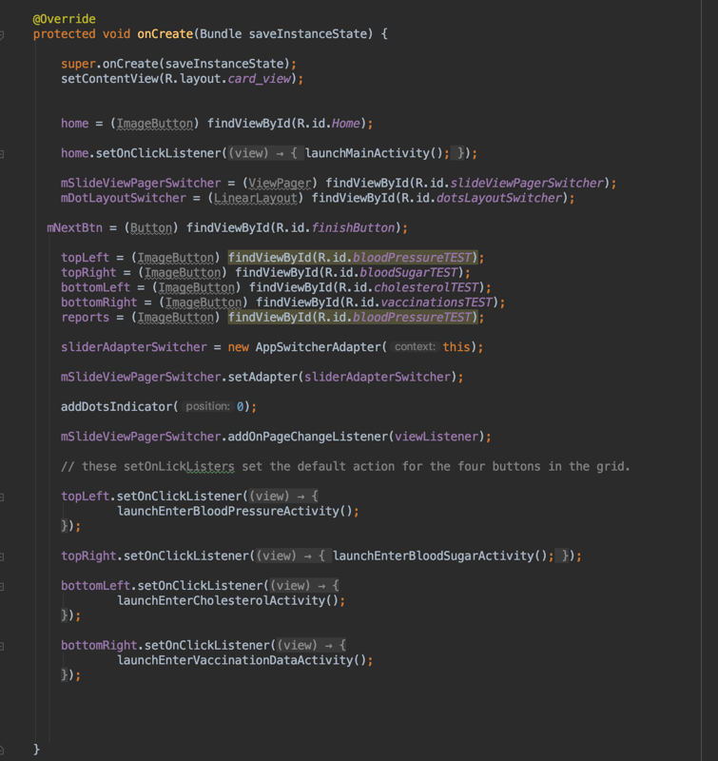

The “destroyItem()” method is also overridden as it will remove the correct view from the container on each page slide.

The second Java class that is associated with the Journal Layout is the “AppSwitcher.java” class. This class inherits multiple methods from the “AppCompatActivity.java” class. The overall purpose of this class is to add the functionality to the visual.

Inside of the onCreate() method the ImageButton(s) are instantiated; as well as the “setOnClickListener()” methods being associated with the initial icons that are shown on the first page of the journal. The code is shown on the right:

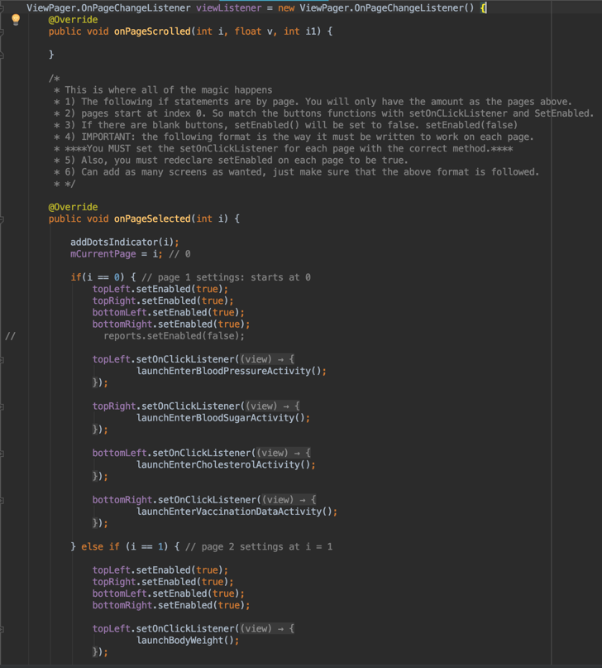The most important part of the “AppSwitcher.java” class however is the next portion. The “ViewPager.OnPageChangeListener” object is instantiated with a method that is ran each time the page changes. Inside of the method, which is shown to the left and bottom, the different portions of the GridLayout change their functionality.

This method looks at the page index of the array **(starting at 0)** and matches the correct “setOnClickListener()” and “setEnabled()” values.

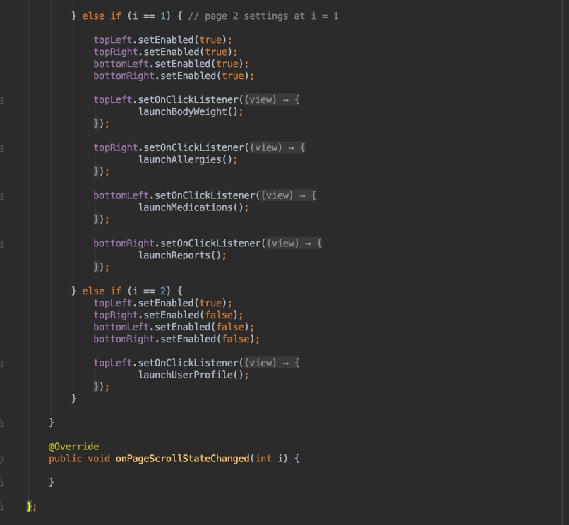The way it is set up allows for the blank icons’ “setEnabled()” values to be set to “false” so they are unclickable, while matching the correct screen to open upon clicking the different icons on each screen.

The final portion of “AppSwitcher.java” is the “addDotsIndicator()” method. This method simply adds the dots to the bottom of the screen and allows the developer to choose the different colors of the dots, as well as highlight the current page. The code is shown below:

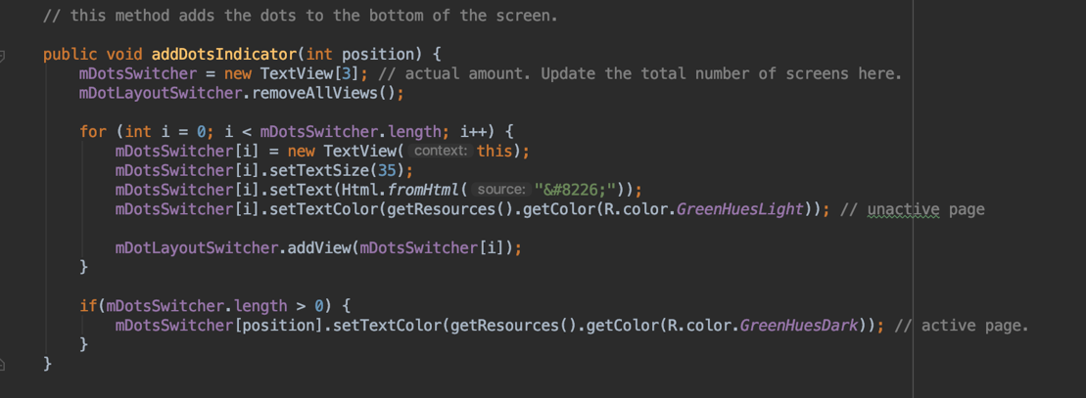

**SQLite Database**

The way that data is stored in SCHealthPlusMe is using a SQLite database. It is lightweight, which means that it does not take any servers or API to talk to, as well as it is secure, which is perfect for locally storing health information to be in align with HIPAA laws.

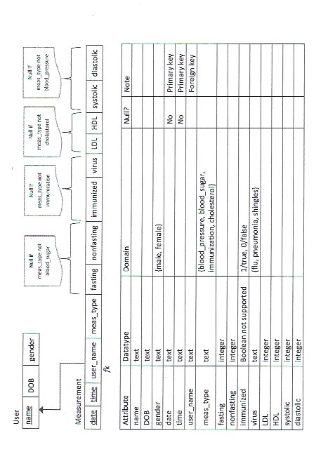With the SQLite Database being a standard part of Android development, there were already methods for creating, managing, updating, deleting, and adding information. Before you can add data to manage however, you must have relations between tables and their data. Below is the ER Model for the basic tablets in SCHealthPlusMe:

The “DatabaseHelper.java” class was created to hold the methods, in java, for creating, managing, pulling, and adding data to the SQLite database. The class extends and inherits methods from the “SQLiteOpenHelper.java” class. Inside of the “onCreate()” method is the code for creating the different tables in the application. The code is showed below:

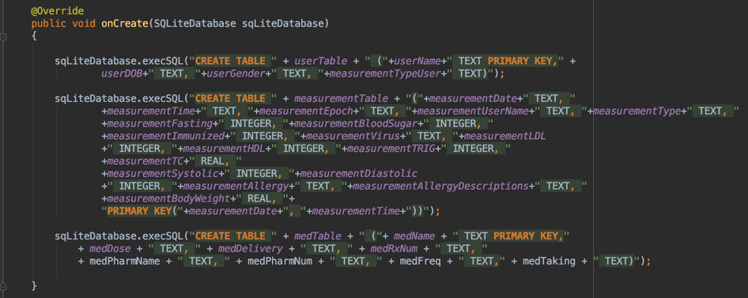

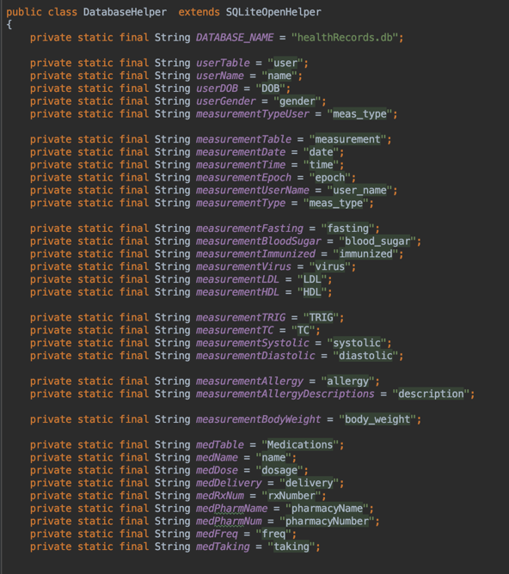The code using a method called “.execSQL()” which passes values as strings in a specific order so that it will create the correct query in SQL. The variables are declared above the “onCreate()” as their database values. These can be anything, but to keep things simple, the variable format that is shown to the right is recommended:

The way that data is retrieved and added is through methods that are for each type of data. Each of the health measurement types have their own methods for inserting and reading data.

The examples below are for inserting, and reading Blood Pressure values:

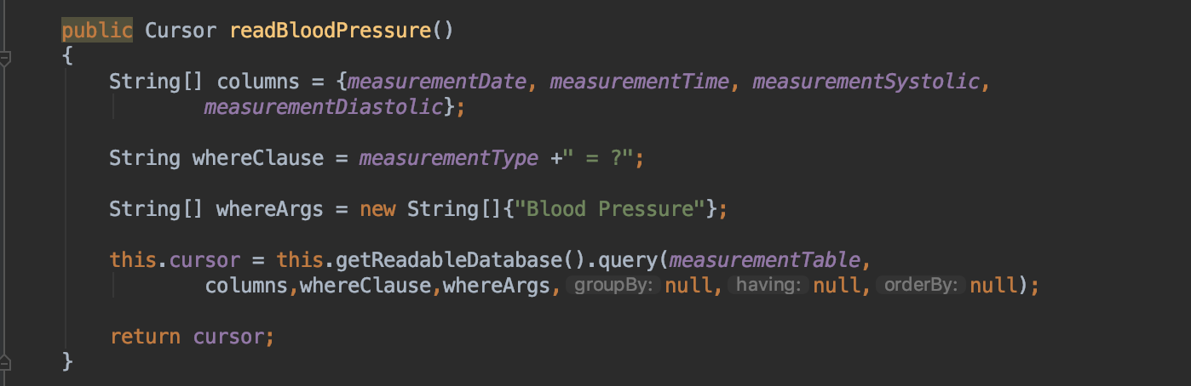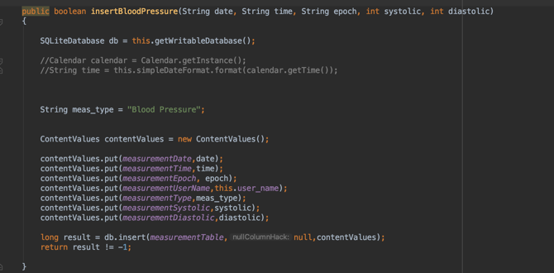

The insert method takes in the different values that are being put into the database, which match the attributes that are declared at the top of the file as mentioned before. Inside of the insertion method, “contentValues.put()” puts the correct values into the correct fields inside of the database tables. The top line gets the correct database, and the result value returns if it was inserted or not into the correct table by the variable passed, as well as the values through the “ContentValues” object.

The read method has an array of Strings for the different columns of data. The next two variables are made to be a part of the “this.getReadableDatabase().query” call which requests which table to read the data from, as well as the whereClause() which can be specified in its String. SCHealthPlusMe does not use any SQL logic in the SQLite database, simply retrieving the data using a Cursor object which will be referenced further in the next two sections.

This is the basic set up for the SQLite database, but the next two sections will cover how the data gets visualized using Graphs, as well as the Card Views for trends in data, as well as individual health measurement viewing.

**Graphs**

The graphs that are used inside of SCHealthPlusMe are from an open source library known as “MPAndroidChart.” The steps to adding this “dependency” to the project is as follows:

1. Go to the [GitHub Library](https://github.com/PhilJay/MPAndroidChart#gradle-setup) for “MPAndroidChart” and look at the documentation.
2. Go to the “Gradle” portion of the documentation, and copy the “implementation” into the “Build.gradle (Module: app)” file as shown below:

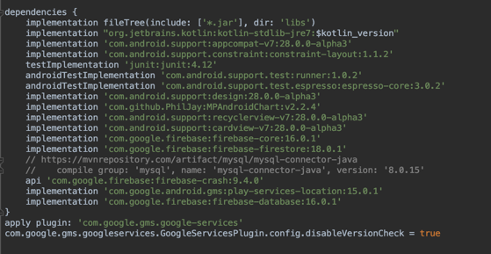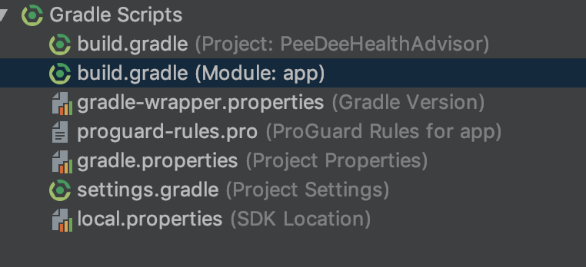

1. Once it has been copied in, sync the build by clicking the “sync” button.
2. It should be ready to go! You will now have the ability to use his methods, classes, and implement all that MPAndroidChart has to offer!

After MPAndroidChart is added as a dependency, then it can be used inside of the application. The way that SCHealthPlusMe uses MPAndroidChart is to display the health measurement data, by date and time entered, over time.

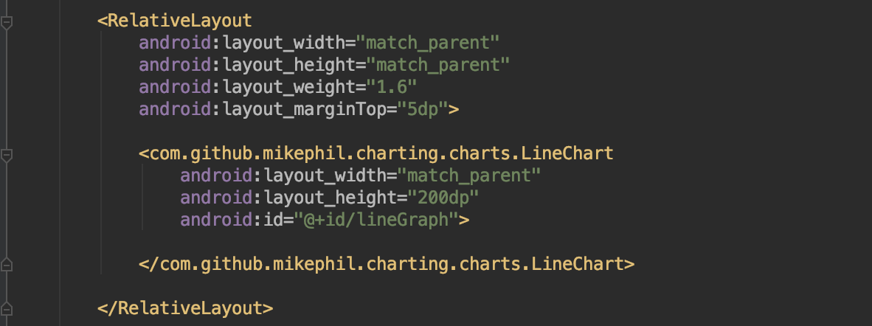The implementation of graphs into SCHealthPlusMe uses the built-in methods that are derived from the MPAndroidChart open source library. The first thing to do is to create a chart or graph in the correlating “.xml” file. The code to the right shows a graph represented in the “blood_pressure_graph.xml” file.

To get the data however, you must first refer to the previous section about reading data with the read method in the “DatabaseHelper.java” class. With that method in mind, it is time to create a Cursor object to traverse the database table for the health measurement data.

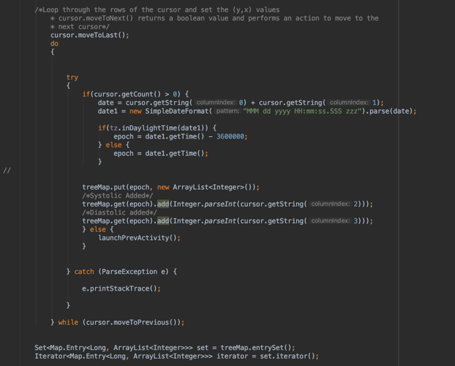In the code to the left the Cursor will loop the main data table (page 16) looking specifically for the Blood Pressure values. These values will then be gather for display by the MPAndroidChart’s methods.

For the graphs, the data is added to a TreeMap<> by epoch time, which will order the values by date and time.

The first element is an ArrayList<> that will hold the epoch time, with the other blood pressure values being added to that specific key in the TreeMap<>.

After the loop, there is a set that will take in each entry in the tree map, and the other two integer values in the form of an ArrayList<>. After that, an Iterator is created to traverse each key and its pair in the TreeMap<>.

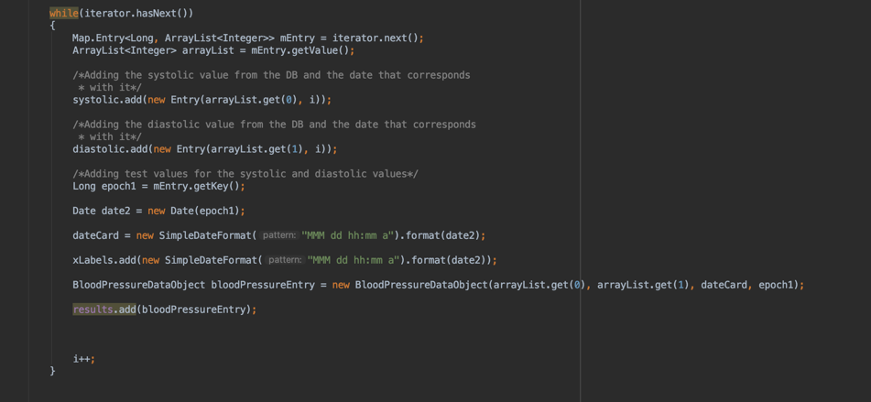

In the code above, the iterator will allow the loop to run until there are no more entries in the tree map, which will make the iterator have no more values to iterate through. On each loop, the different values that are being displayed are set, as well as the “BloodPressureDataObject” for the CardView, but that will come later. Each label is stored in an ArrayList<> that corresponds with the data type and on each loop, the correct labels are added with their respected entries in each ArrayList<>.

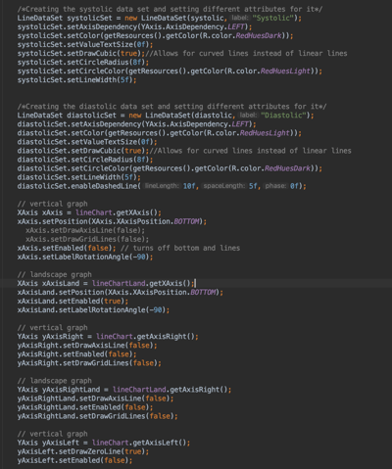After the two loops for adding the data is the graph’s attributes and methods. To the right is the creation, and visual appearance of the data that is being retrieved from above.

There is a vast library of modifications that are available with the way it looks and acts. To the right is the current format for the vertical, and horizontal graphs using the built in MPAndroidChart library methods. Below is the code for the visual attributes:

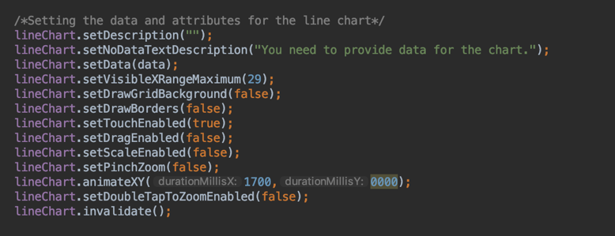

**Card Views**

The Card Views require three separate Java Classes (**BloodPressureGraph.java, BloodPressureDataObject.java, MyBloodPressureRecyclerViewAdapter.java**) and works with two “.xml” files (**blood_pressure_card_row.xml, blood_pressure_graph.xml**). The Card View system is first set up by instantiating a RecyclerView in the “**blood_pressure_graph.xml”** file. It would be recommended to put the RecyclerView inside of a RelativeLayout to keep the cards organized on a certain position on the screen. This code is shown below:

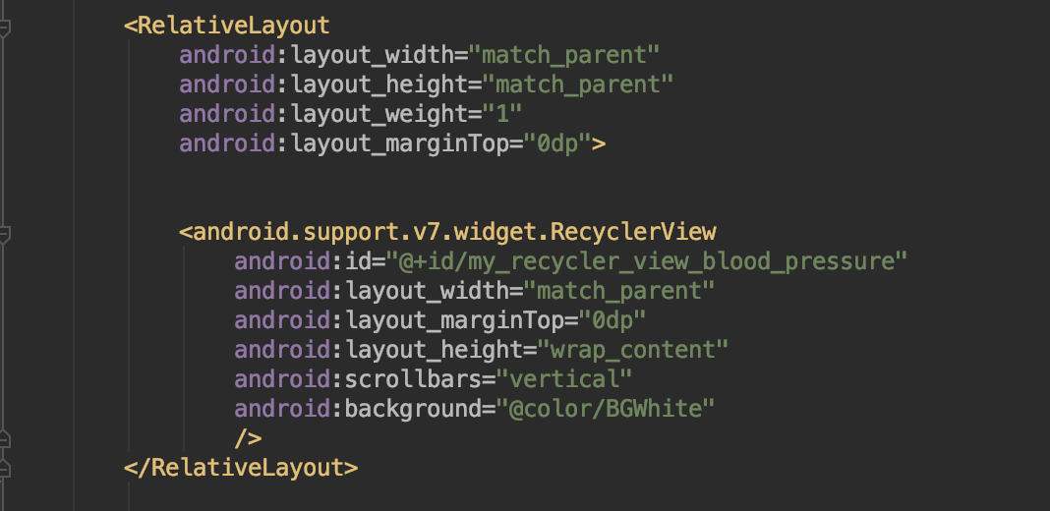

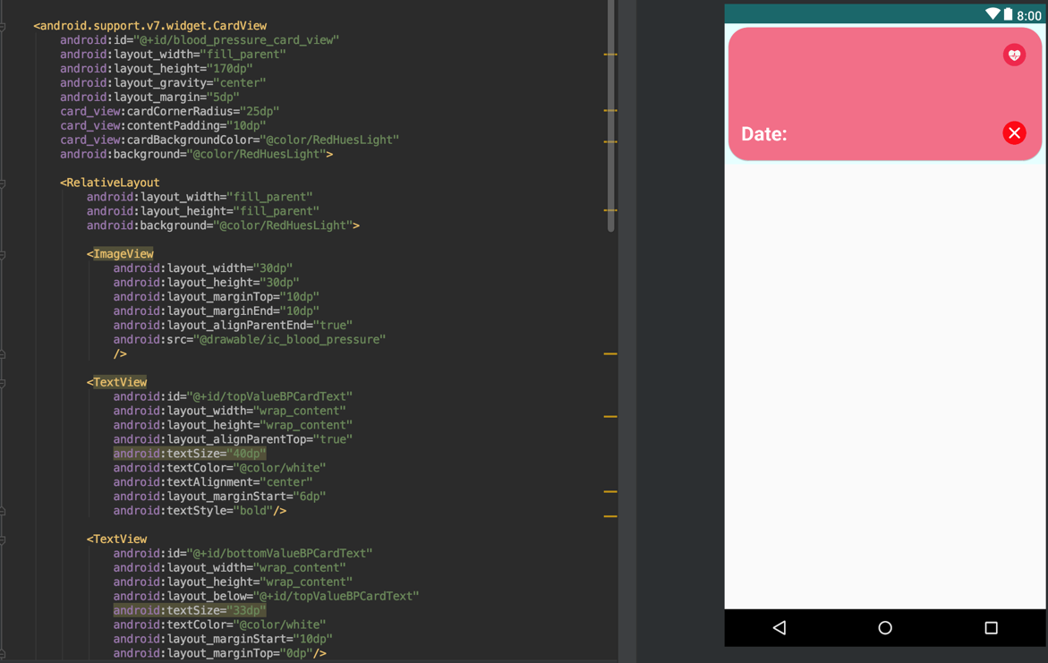Once the RecyclerView is set up inside of the .xml file, it’s time to create the “**blood_pressure_card_row.xml”** file. This file will be the design of the Card, as well as setting up the “hooks” for the data that will be displayed onto the card. This is a fairly easy process, and fun if you enjoy design. The most important thing about this file is setting up the CardView itself using the “<android.support.v7.widget.CardView” attribute. All of the design elements go inside of the CardView. Below is an example of a CardView being set up, as well as some design properties inside of the CardView:

An important thing to note is you must set up TextView(s), or ImageButton(s) inside of the CardView to hook to the Java code that we will mentioned later. TextView(s) should be left blank as the “**MyBloodPressureRecyclerViewAdapter.java”** class will put the text into their placeholders. ImageButton(s) functionality will be added in the above Java Class as well.

The next part is to create the “**MyBloodPressureRecyclerViewAdapter.java**” class. This class will hold the different data attributes that will be displayed to the CardView(s). It is important to note two things: 1) Each Card is created using the above class on a call by associating the “**blood_pressure_card_row.xml”** file to the Java class. This makes adding unique functionality to individual Card’s buttons tricky, but we will cover how to get around this. 2) The set up for these card views are simple and reusable for all types of data inside of the application.

Creating the class beings with extending the class from “RecyclerView.java” which takes on the methods required for each card. Below is the initial portion of the class, but some key aspects are:

* ArrayList<BloodPressureDataObject> mDataset holds the individual data objects that are wrapped with the different groups of data that each card will display, as well as the time for ordering.
* The BloodPressureDataObject.java class will be created next, but it’s easier to create the “**MyBloodPressureRecyclerViewAdapter.java**” class then “fill in the blanks.”
* “Context context” is needed to get the current card’s context so it can be created.
* The constructor associates this context to the current context being passed, so it will always have the correct connection to the correct card.
* The “DataObjectHolder” class extends the “RecyclerView.ViewHolder” which also implements the interface of “View.OnClickListener”, which is once again going back to the context being associated to the current view, so everything will work correctly.
* Inside of this class is another constructor that takes in the view of the current card, and this is where the Java instantiation of the different elements from the “**blood_pressure_card_row.xml”** are connected. Each element created above the constructor is then set to an “.xml” element.
* “deleteButton.setOnClickListener(this)” is required for the button to understand the correct View and context.

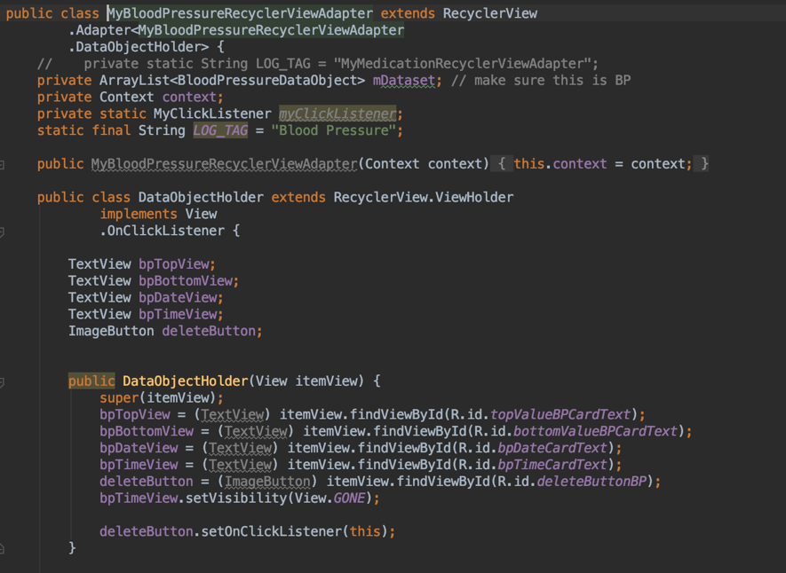

After the constructor, there is an onClick() method that is inherited. Inside of this method is the code for deleting the individual cards after being pressed. This is created with the “alertDialog()” class and set of methods. This is a popup that appears after clicking on the card. Once again, this brings in the Intent class. This sets up the deletion button and a message. It also gives the Intent for the deletion, as shown in the code below:

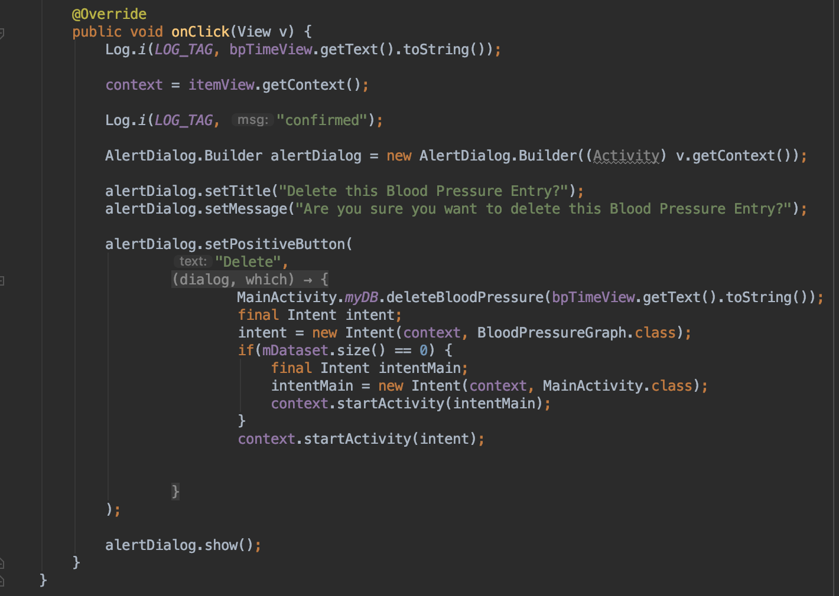

This is the end of the inner class, but there are still a few methods that are required to be overridden for the main class:

* “setOnItemClickListener(MyClickListener myClickListener)” sets the passed myClickListener() to the current one.
* “MyBloodPressureRecyclerViewAdapter(ArrayList<BloodPressureDataObject> myDataset)” sets the passed dataset to the current one. This is extremely important as it references to the correct dataset.
* DataObjectHolder onCreateViewHolder() is one of the most important parts of the class. The method sets the layoutInflater() to the “**blood_pressure_card_row.xml”** which means that the file is set as the file that is referenced with all of the code used in this class. The rest of the method is to be followed as shown.
* onBindViewHolder(DataObjectHolder holder, int position) is also **extremely** important. This code is crucial to all different aspects of the CardView as it takes in the current position of the ArrayList<> of BloodPressureDataObjects and assigns the correct data to the TextView(s), and the correct functionality to the correct ImageButton(s), so the correct value is deleted out of the database using the getter methods. In this example however, we simply just get the text for the TextView(s), with the onClick being called within the class. Later we will discuss the other ways to associated a button with Intents.
* getItemCount() returns the size of the ArrayList<> of BloodPressureDataObjects
* The rest of the methods are not used, but can be filled in as shown in the code below:

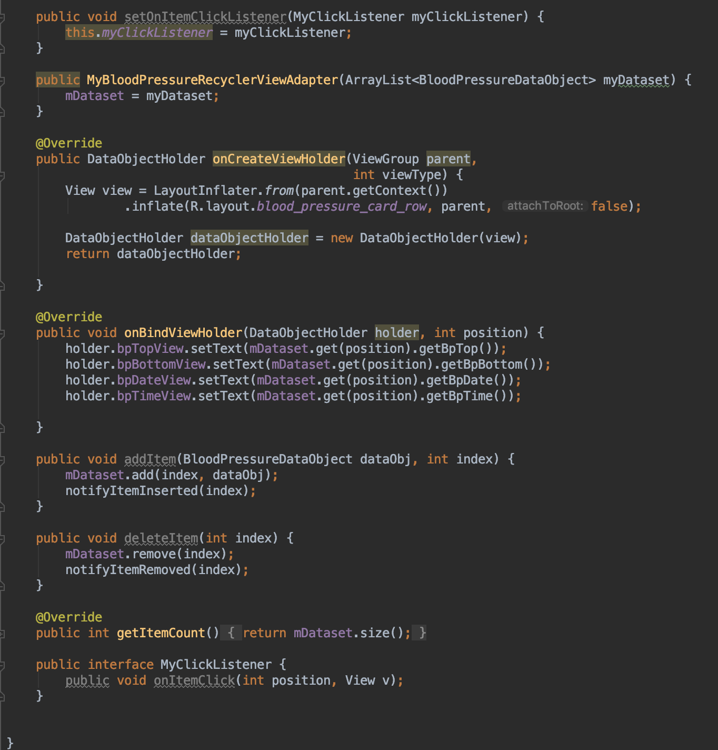

The next portion is to create the “BloodPressureDataObject.java” class. This is a simple Java Class simply made up of the setters and getter methods (referenced in the onBindViewHolder() method above). Simply follow the code below by creating a constructer to take in the data values (which we will call in the BloodPressureGraph.java class on each loop as it creates the graph) and set the passed values to their new values. Then create getters and setters which is easily accomplished in Android Studio by right-clicking on the variable and clicking “Generate.” Below is the code for the class:

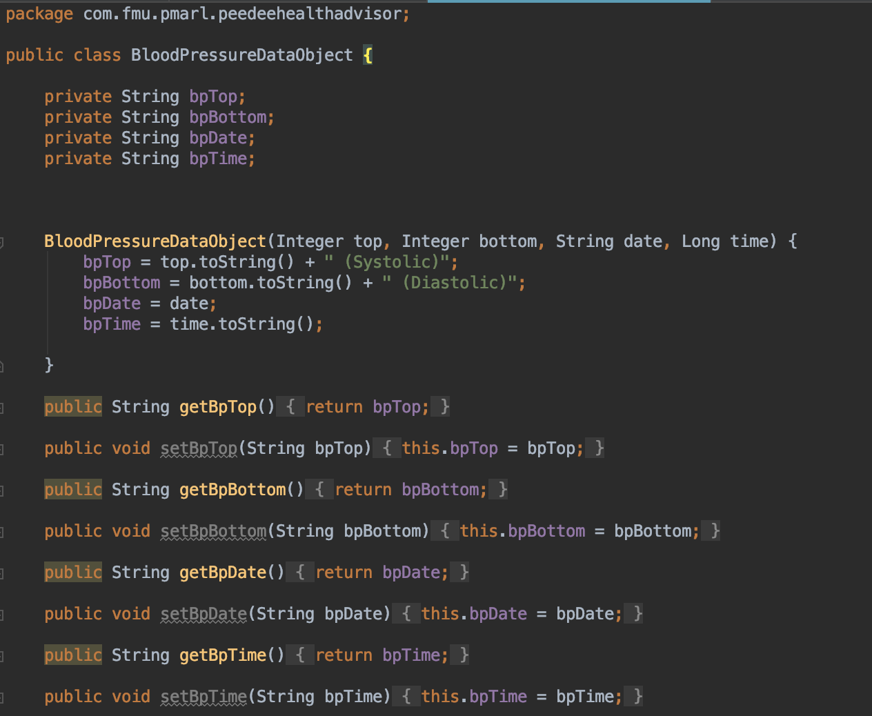

The final portion of this system is getting the beginning of the call started inside of where the Database is being called.

For this example, the values are retrieved form the “BloodPressureGraph.java” class. Inside of this class we have to set up the RecyclerView, have an ArrayList<> to store each BloodPressureDataObject, and then call and create an object inside of the iterator loop getting data from the TreeMap<>.

**Note:** This is very specific to the functionality of the data inside of the journal. Other examples, such as the Medications and Allergies do not have the TreeMap<>, so they will simply create the data objects inside of the Cursor loop getting data form the database.

The first portion is just initializing the ArrayList<>, and all of the RecyclerView attributes, as shown below:

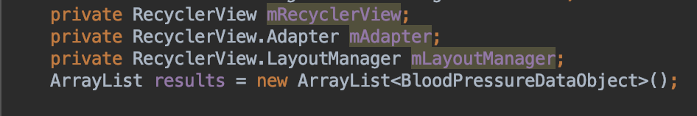

Then, set the RecyclerView attributes to the correct values. It is very important to make sure the correct id is referenced (with the Recycler View being created in the “.xml” where it will be shown so for this example it will be in “**blood_pressure_graph.xml”**:

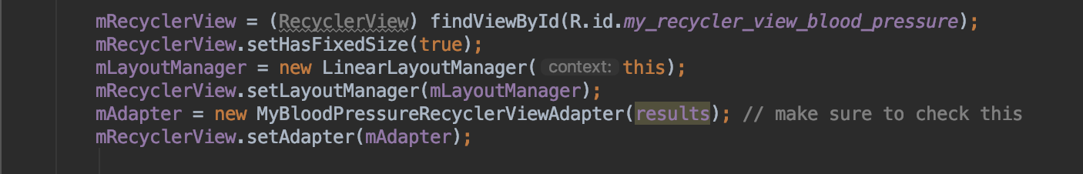

After this, simply add the creation of the object to the iteration loop, and then add that object to the ArrayList<> that was created above:

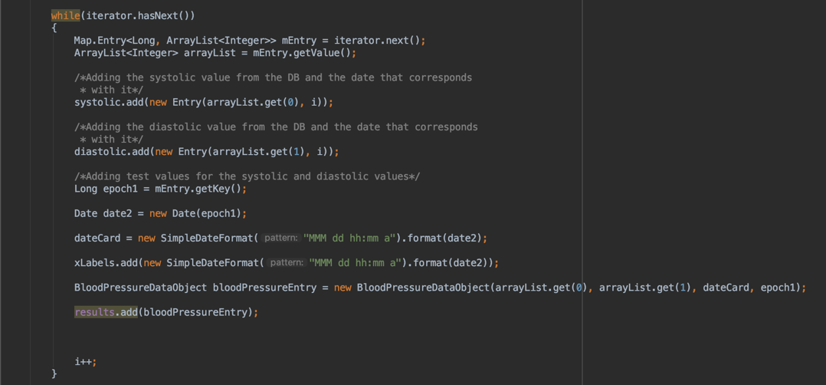

After this call, the card view should be set up. The other Card View for the Health resource portion will be discussed in a later section, but all Card Views take this system of Java Classes, and xml files.

**Report Screen**

The reports screen is one of the most intuitive portions of SCHealthPlusMe. All of the data is displayed on a single screen inside of an easy to read format.

The Reports screen utilizes the Cursor object, as well as the different “DatabaseHelper.java” read() methods for pulling information from the database. These are mentioned on page 17. Each different type of Health Measurement that is on the reports screen has its own read method to pull the data.

The magic of the Report Screen is the different colors, the organization, the health measurements, and the dynamic ability to grow over time.

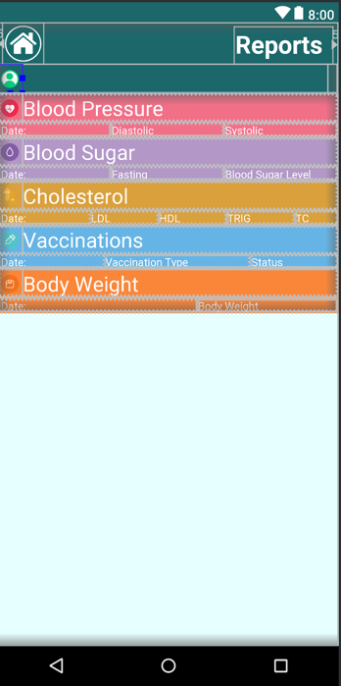

The start of the functionality begins with the “.xml” file. This is where all of the design takes shape and is key to getting the data into an organized, symmetric order.

Each section of the report screen data is inside of a ScrollView. This allows the screen to become scrollable when the data exceeds the limits of the screen. To the right is the screen and how it is spilt up and organized:

Each individual heath measurement section is split into a couple of different LinearLayout(s) and placed inside of the ScrollView mentioned above. Below is the code for the Blood Pressure section on the report screen, with the top LinearLayout withholding the Icon, and “Blood Pressure” text being first, with the titles for the individual entries being second:

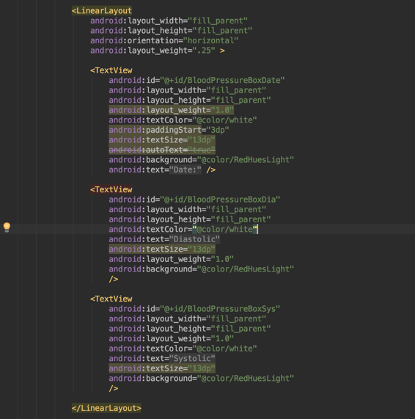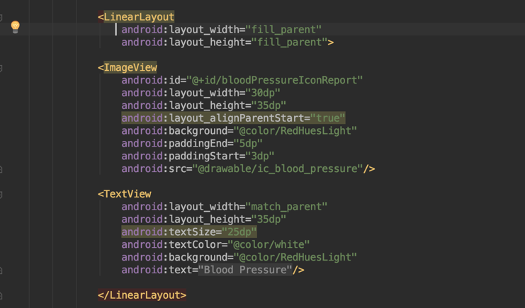The next portion is the “ReportsActivity.java” class. This class is actually simple to follow. The first thing in the class is the initialization of the different Cursor objects, and the “.xml” reference objects that refer to the “activity_reports.xml” file. This is repeated for all different sections of the reports screen. These initializations are shown below:

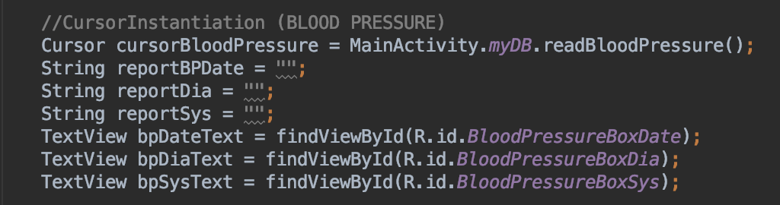

Once they are referenced, the Cursor loop, and connection to the DatabaseHelper.java class can be created, as shown below:

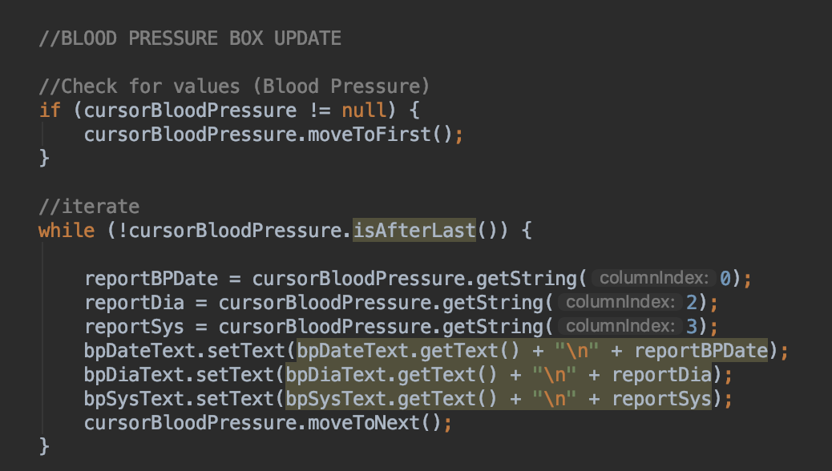

The algorithm simply reads the data from the database and adds the entries to the different TextView elements that are already there. This keeps everything organized and straightforward. The first if-statement is a check for if there are no values in the database. If there are none, it will not run the loop, but there are, things go as planned.

One side note to mention is that for the Flu Shot values it is stored whether you have taken the shot or not as a Boolean 1 or 0, meaning yes or no. To change this to the correct language, you must do an if-statement inside of the while loop, similar to the one shown above, and set the text with the setText() method to “Yes” or “No” depending on the result. The “\n” created a new line, which is how it appends to the TextView so perfectly. That Is the Reports Screen.



The Health Resource portion of SCHealthPlusMe is a simple way for users to find local health resources, sorted by closest distance, and easily get directions for the health measurement of their choice. The way that the user is able to dictate what resource type they are searching for stems from the initial Selection Screen.

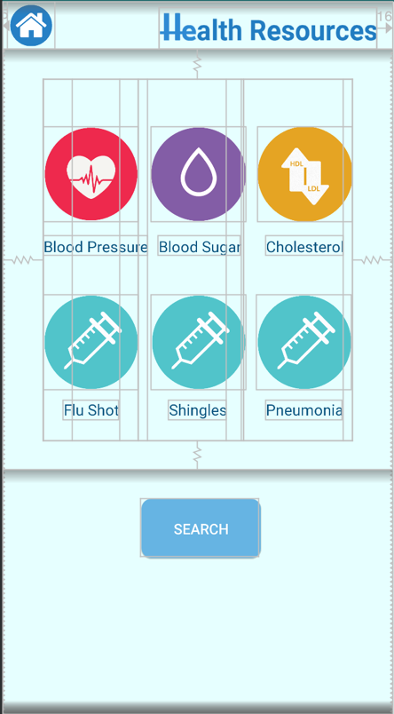The way that the screen is designed in the “activity_search_service.xml” file is simply a GridLayout. The GridLayout places the icons, and the text underneath, into a specific order that will look organized. To the right is the setup of the screen though the “.xml”:

The GridLayout contains the icons, as well as the text. Each of these have similar attributes in the “.xml”, with the GridLayout having a specific style with attributes as well. This allows the correct number of items be displayed with a sense of organization.

The entire GridLayout is contained within a LinearLayout, with the top bar being a RelativeLayout as on all of the other screens.

The Search Button simply takes the app to the results screen, but first we are going to go over the layout’s design attributes, as well how we get the user to understand they have clicked an item button for selection. The code that is below shows the way that the Image Button(s), and TextView(s) are written inside of the GridLayout. Note the GridLayout’s attributes and this is only the top row:

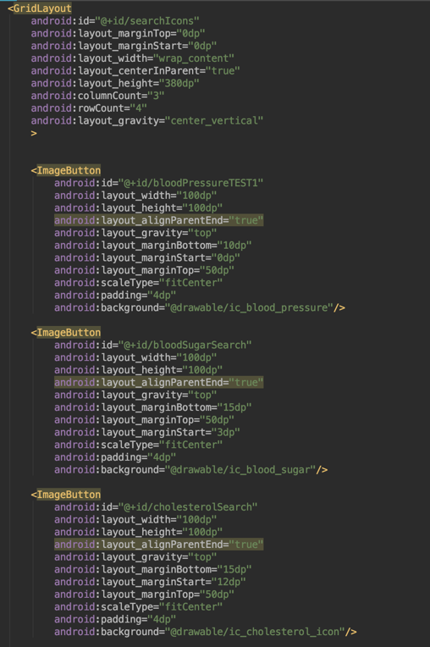

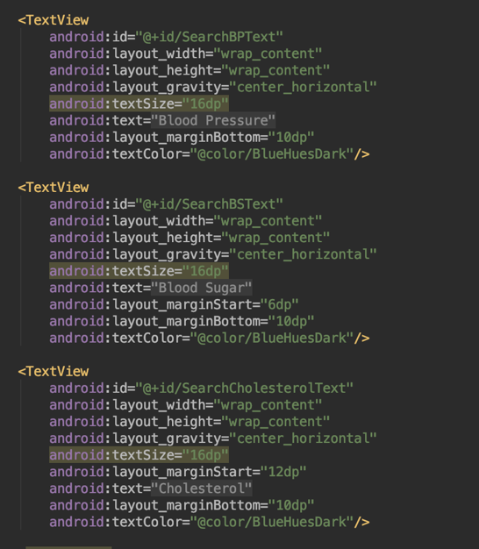

To give the user a sense of feedback, the buttons needed to change once clicked. The best way to get across to the user that they have made a selection is for the button to change its appearance. A simply faded out button with a checkmark is a clear way to get this across to the user.

This is where the “SearchServiceActivity.java” class comes in. This is the Java Class that does the logic attached to the “activity_search_service.xml” file. The individual buttons have two purposes: One to be to change the appearance of the buttons, but two, and most importantly, change the value of a Boolean variable that will allow for that specific health resource to be included into the query into Firebase.

First though let’s go over the changing of the button’s appearance. Both appearances of the buttons were designed in Photoshop. It is important to note that they are different images and this way of changing the appearance is simply changing the image based on an setOnClickListener() and Boolean value. The image will change on each click, with the previous Boolean value determining which image comes “next.” This allows the button to be changed infinitely many times as the Boolean values’ states are constantly switched along with the images. The default appearance is unchecked, which means “clicked” is false. Each button’s corresponding Boolean value is initially set to false as shown below:

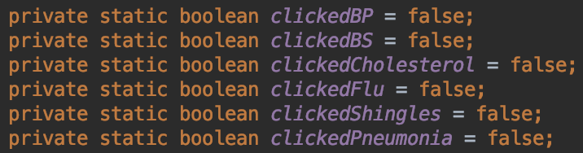

The algorithm for changing the image, as well as changing the Boolean value is shown below:

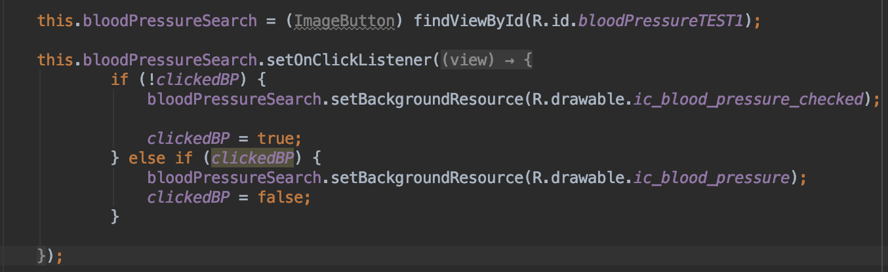

This code is used for all six ImageButton(s). It first references the button inside of the “activity_search_service.xml” file. Then the button is assigned a setOnClickListener(). Inside of the setOnClickListener() is an if-statement with an else that will catch the value regardless of its state. In each portion of the if-statement is an assignment of the Boolean value to its corresponding value. This allows for the Boolean to be assigned the correct state for the query.

If the button has been checked, it changed the appearance of the button; else if it is its default value of false (or unclicked) so the image stays with the original. Note that the (!clickedBP) may seem confusing at first, but this logic is saying “not-clicked.”

Inside of this class is also the permission check of using the users location. This is accomplished by the code below:

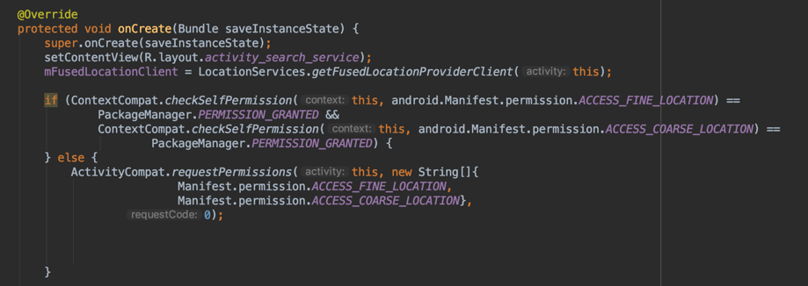

This code is mostly “copy-paste” generic Android code that is widely used. It is important however to make sure the permission for the location is present inside of the “AndroidManifest.xml” file as shown below:



The code for the Location Permission check will prompt a box asking for permission. If it is not given, you must catch that, but that will come within the Algorithm which is in another class.

The final portion of the “SearchServiceActivity.java” class is to make sure that the Boolean values are reset to their default values if the screen is restarted by chance. This is simply by placing the following code inside of the OnRestart() method as shown below:

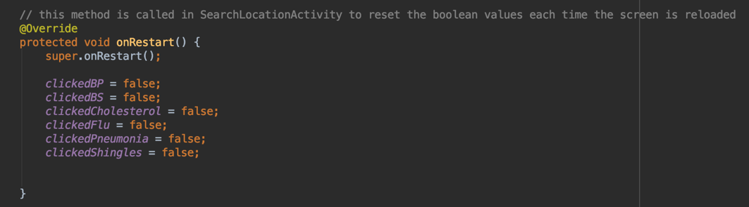

One final check is if no health measurement buttons have been clicked, and the search button was pressed. If this was not checked, the results screen would not have anything to query! The code is a simply check for if all of the buttons are set to false (or unclicked), and if so, displaying an error toast message as shown below:

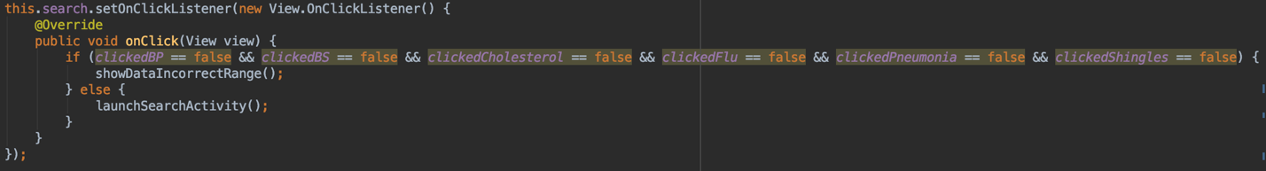

Next comes the most intensive, and computational portion of SCHealthPlusMe. It uses most, if not all parts that are taught in basic Java classes at a university level, but it is a simple algorithm to follow.

In this section we will go into the results portion of Health Resources. This is where Firebase will do its magic work.

The first part of Firebase is to get a connection. This is assuming you already have a Firebase instance created online. If not, simply create a new Firebase Firestore at firebase.google.com and Google will provide easy steps to the creation. We are going to pick up after creation.

The connection of an application to the Firebase Firestore is a step-by-step process that begins with going to the Firebase instance online at: “firebase.google.com”.

Once there, you are able to go to the Firebase Console.

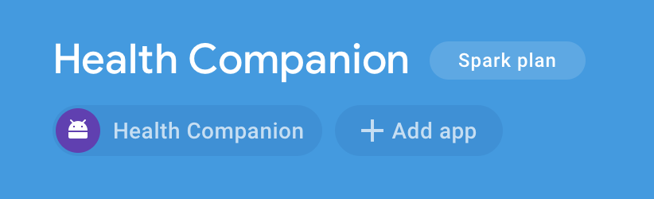Click on “Add App”

The following screen will appear. Fill out the information and follow the steps:

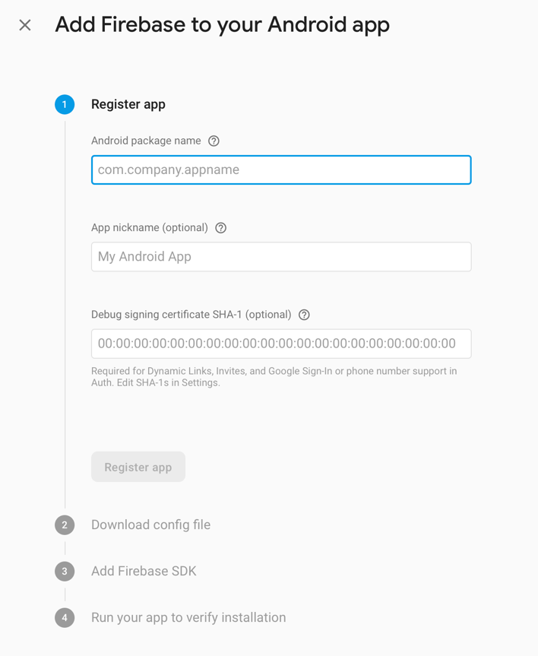

After following these steps, the app should be connected and ready to go!

The results from the Firebase Firestore database are displayed in a CardView format exactly as described before (page 20). Once again, there are two “.xml” files named, “activity_card_view_search_services.xml” and “activity_search_services_card_row.xml.”

There are also three Java Classes named, “MySearchResultRecyclerViewAdapter.java”, “SearchServiceDataObject.java”, and “SearchLocationActivity.java.”

Both the “MySearchResultRecyclerViewAdapter.java” and “SearchServiceDataObject.java” classes follow the same format as shown in the CardView section with the former setting up and connecting to the RecyclerView element that is inside of “activity_card_view_search_services.xml”. The latter is simply creating an object that withholds the data that will be displayed on the individual cards, as well as the button’s functionality.

The majority of the new material in this section will come from the “SearchLocationActivity.java” class, which is the class that connects and pulls data from Firebase, but the “MySearchResultRecyclerViewAdapter.java” class contains a few important differences that are key to this functionality.

The first portion of the “SearchLocationActivity.java” class is creating the different variables, and objects that are required for the algorithm, which is shown below:

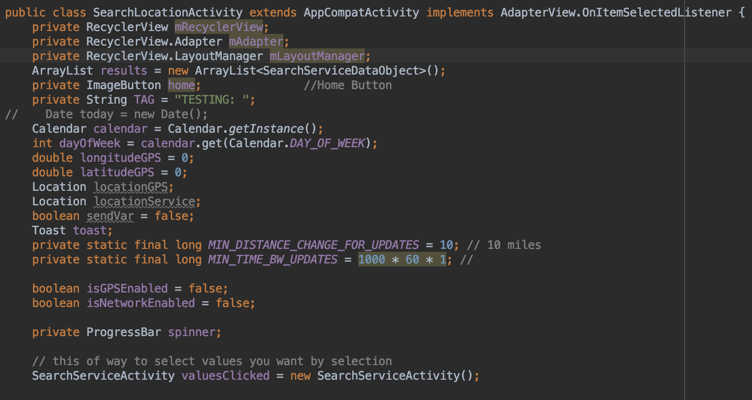

The ArrayList “results” is what holds the different location objects and is extremely important. The rest of the variable are initialized for use, but there is two constants:

* MIN_DISTANCE_CHANGE_FOR_UPDATES is the amount of miles in integer form that the phone will update the GPS location in the LocationManager, which will come later.
* MIN_TIME_BW_UPDATES is the amount of time the GPS will request to update. This is set to one minute with a conversion from microseconds, times 60 of them.

The Boolean values for the GPS are both set to false so they can be set to true after it is requested. Also, the ProgressBar is initialized so it can be used inside of the algorithm.

After the variables are initialized, the Firebase instance is created so it can connect to the database. The code is shown below:

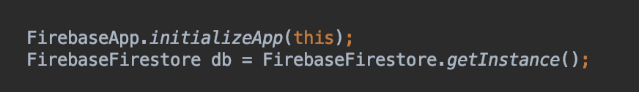

This will return the instance of Firebase that is created and the application is connected to.

Then comes the beginning of the algorithm of how the data is pulled from Firebase. The beginning of the code is using the FirebaseFirestore() instance that is created in the code above.

The code will be split into different images, with context given around said images:

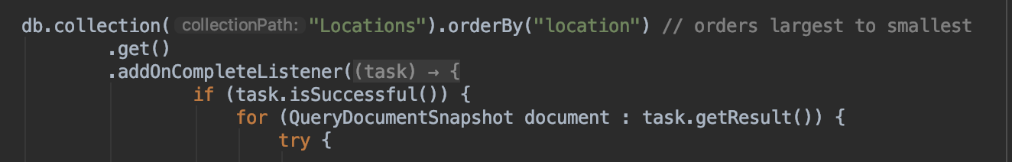

The code above uses built in methods with Firebase that are installed when you connect to Firebase in the previous section. “db.collection” accesses the online collection, which is a table in NoSQL, and the “orderBy” will order the JSON objects inside of that collection by the location attribute. This is overridden by another method that was written inside of this class. The code above is a standard piece of code that is common for Firebase. What is done inside of this code is what is most important.

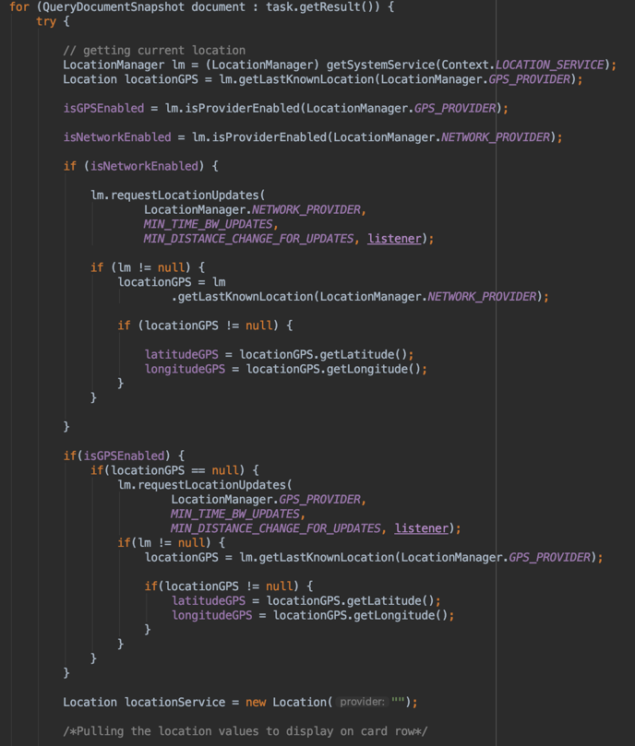The code to the right is the first portion of the code inside of the “db.collection” call. It is placed inside of a “try-catch block” to catch a SecurityException(), which is required due to the phone, and application, accessing the GPS location. After this, there is a LocationManager() that is created. This object is what the application uses to access the GPS location and all of its attributes and methods. **Both of these instantiations are extremely important.**

The GPS Booleans mentioned on the previous page are accessed and switched to true depending on whether Wi-Fi or Cellular data is turned on for the phone to use. Both of these use the LocationManager() instantiation. The next two if-statements determine which type of connection is active (Network or Cellular) and use that part of the device to find the location to pass the Latitude and Longitude later in the algorithm to find the current location.

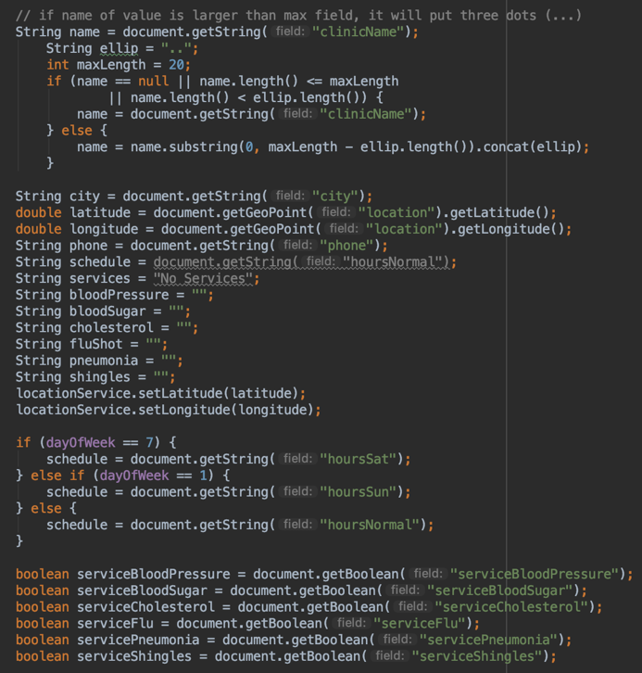The next portion of the algorithm is simply pulling the different values from the Firebase Firestore and storing them into variables.

At the top is code to keep all names within a certain length so they won’t be too long on the Cards once they are displayed. The best value is 20 characters.

The String values for the Boolean values are only initialized at this stage as they will get their text set based upon their Boolean value. Those values are pulled at the bottom of the code on the right:

Below is the code for checking the values of the Booleans, and then appending those substrings to the “services” String, which is the one that is sent and displayed to the card. If all of the Boolean values are set to true, then “All Services Available” is sent to the String “services.”

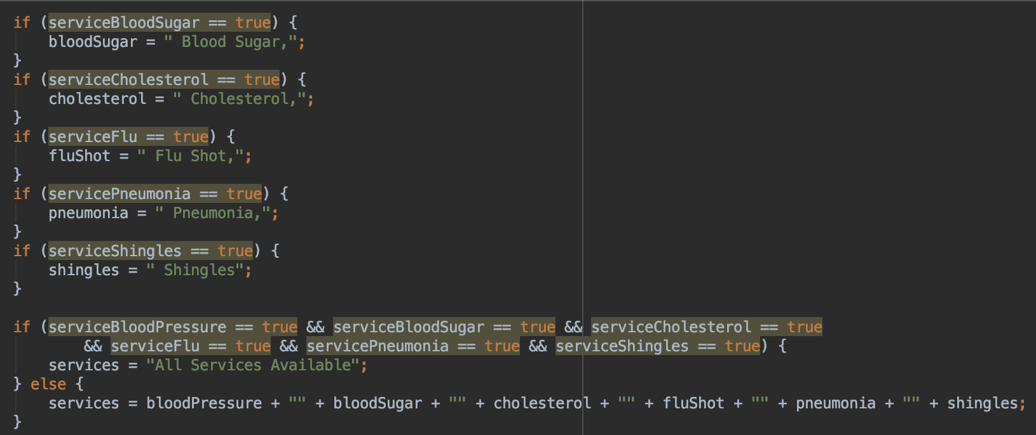

Next comes those Latitude and Longitude values that are sent from the GPS and the LocationManager(). In the code below, those values, which are set to the object “locationGPS”. Setting this object, using the built-in Java method “distanceTo” to the individual locations that are pulled from Firebase on each loop, returns the miles to the location. This value is set to the variable “distance” as shown below:

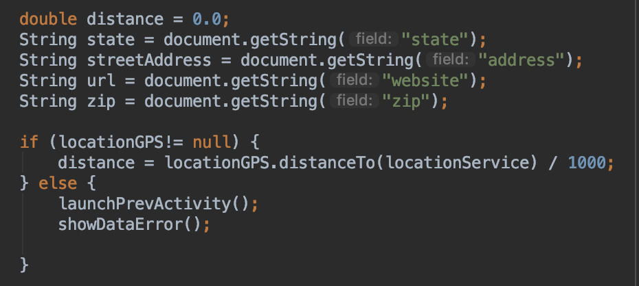

The next portion of the algorithm is creating the “address” String by simply appending all of the individual Strings together. Below that is the object instantiation to create an object of each location on each loop.

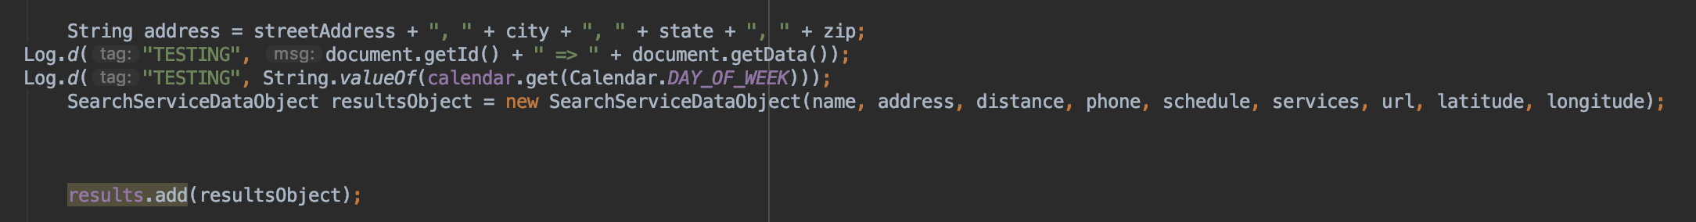

The “results.add(resultsObject)” call is adding each object to the results ArrayList<> at the end of the loop.

Everything up until this point has been straight forward, but there are some key things to remember:

* Locations should be ordered by closest distance.
* The selections from the previous section have to have influence on what is displayed.
* If a location has multiple services offered, then it should not show up twice.

All three of these challenges took some thinking to overcome, but the result is a method that sorts the location objects by distance, a method that sends the “results” ArrayList<> to the “MySearchResultRecyclerViewAdapter.java” class to be displayed, and a method that removes the duplicate locations.

First let’s talk about the “getSortedLocationByDistance()” method, which is shown below:

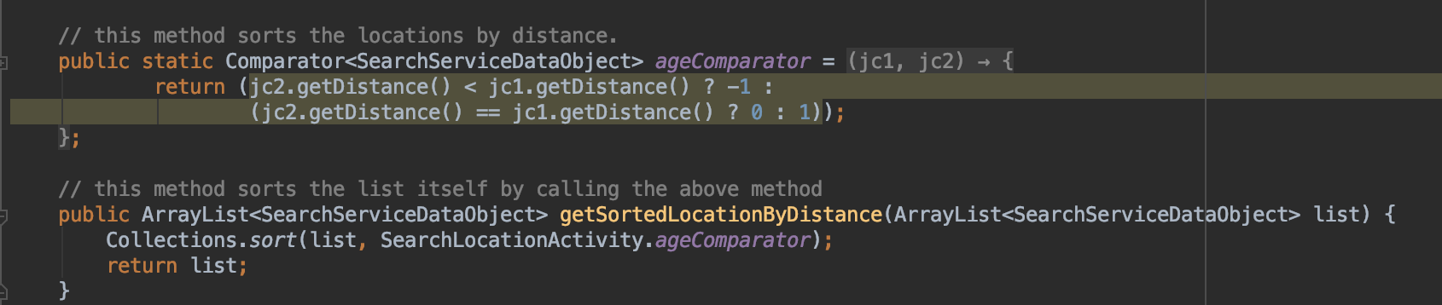

There are two portions that are required for this method to work. The first is the Comparator, which takes in a Location Object (SearchServiceDataObject). It compares both values by subtracting one from the other, with the smaller value being negative, the larger being positive. This is not directly called in the code, but it is called directly below it in the “getSortedLocationByDistance()” method.

Here it is used in the Collections.sort() call, which is a native call in Java. The first parameter is the list in which is being sorted, with the second being the manner in which it should be sorted. Using this two-step process, the list that is passed as a parameter to the “getSortedLocationByDistance()” method is sorted by the distance!

With there being a selection screen for individual services, there has to be a way for them to be selected and filter out the unwanted services. This means if Blood Pressure is searched, all locations that offer the Blood Pressure service will be in the results.

This is where the send() method provides its functionality.

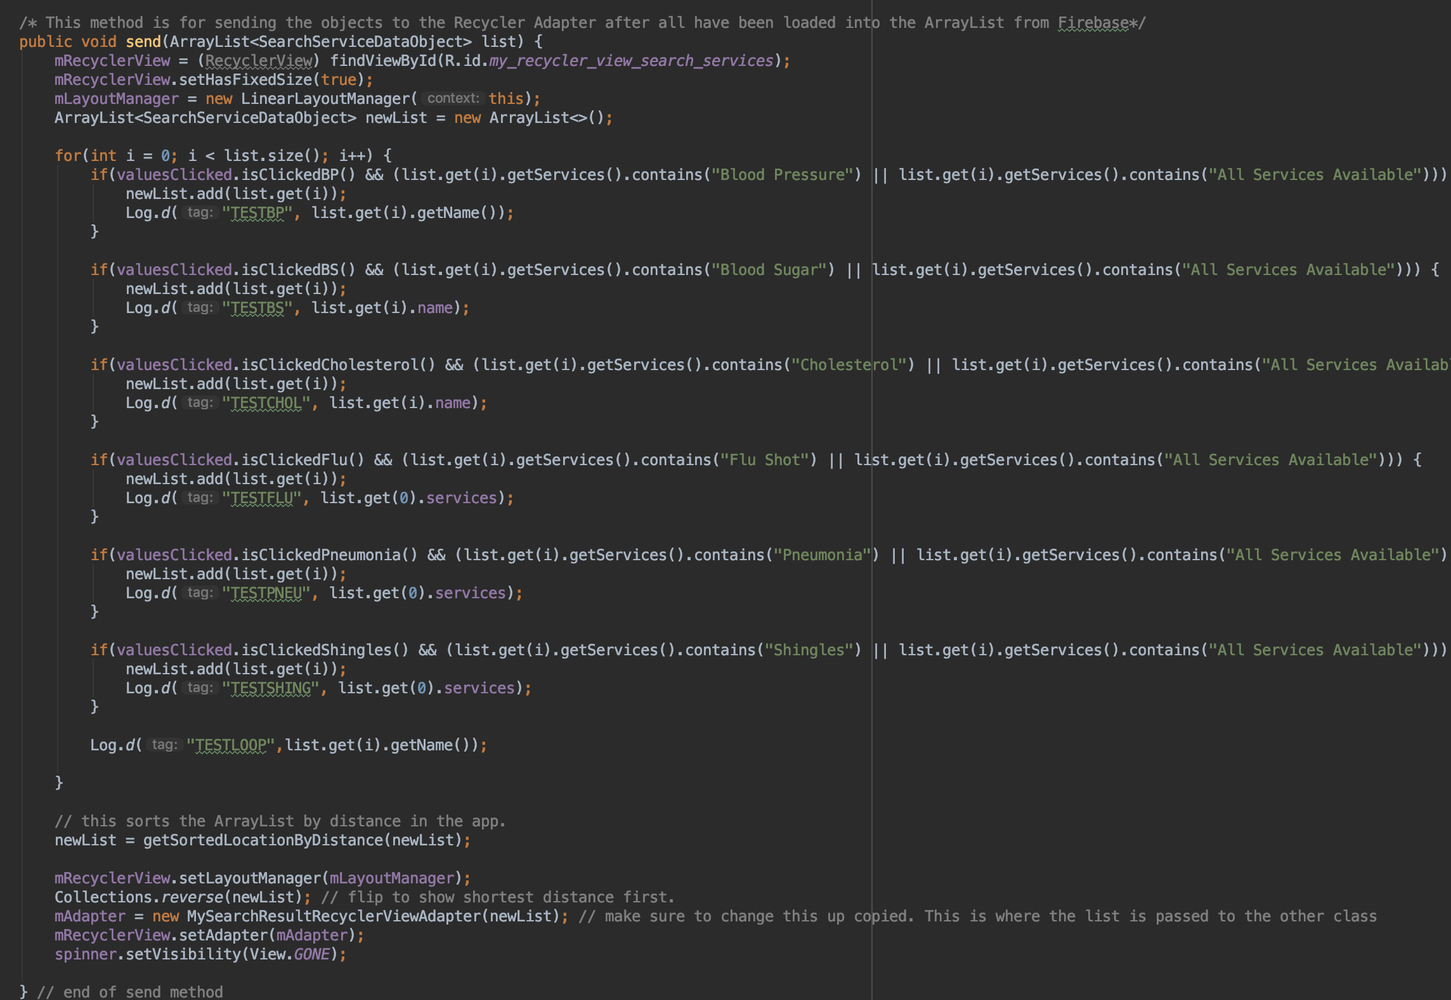

The send() method takes in an ArrayList<> as a single parameter. This method is used to send the “MySearchResultRecyclerViewAdapter.java” class the ArrayList<> in the form of an adapter.

The code at the top of the method is referencing the RecyclerView that is inside of the “activity_search_services_card_row.xml.” file. Below these three lines, a new ArrayList<> is created. Then there is a for-loop. Inside of the for-loop is a check for the current Boolean values state. **Those states will carry over to this class and screen from the previous section and are accessed by the valuesClicked() object.**

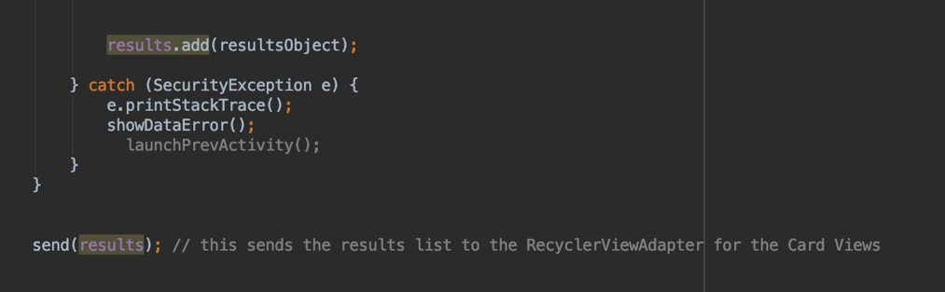

There is also a check for what services are offered. As a reminder the send method is called at the end of each loop as the application pulls information from the Firebase database, as shown to the right:

If both of those services are true, then the current location is added to the list that gets sent to the “MySearchResultRecyclerViewAdapter.java” to be displayed. Before it is sent however, Collections.reverse() is used to reverse the locations to be closest first. The mAdapter is set to the “MySearchResultRecyclerViewAdapter.java” object, and then the adapter is set.

The spinner.setVisibility(View.GONE) makes the loading spinner go away once the View has been loaded. It is called the first time at the top of the OnCreate() as shown below:

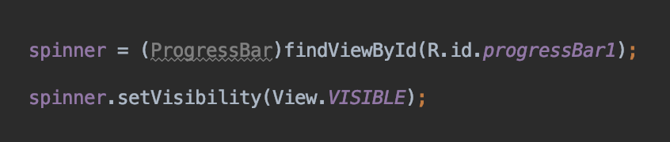

There is one final method and that is to remove the duplicates. This is done in the “MySearchResultRecyclerViewAdapter.java” class itself.

A method, named “removeDuplicates()” was created. It takes in a single ArrayList<> as a parameter. It is a simple algorithm that uses two for-loops that search the ArrayList<> for duplicate objects. These are determined by the phone number, so if they match, one of them is removed. The code is shown below:

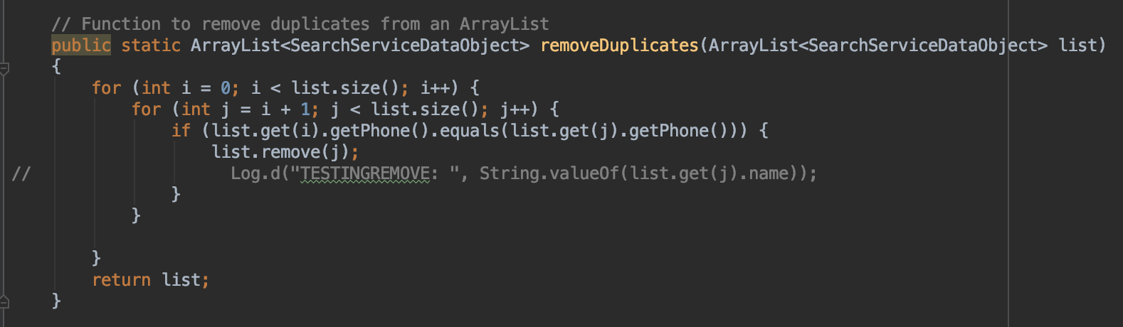

The list is then returned. This method is called inside of the constructor. As described inside of the code and its comments as shown below, the method is called twice to eliminate the one card that is “skipped” in an edge case situation with a specific amount of services clicked.

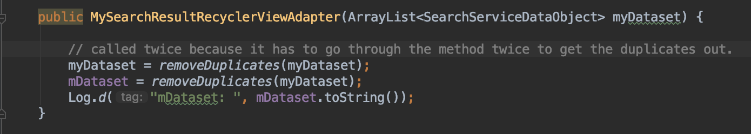

The remainder of the “MySearchResultRecyclerViewAdapter.java” class is identical to the other CardView described earlier in this documentation.

The final portion of this part of SCHealthPlusMe is getting the Buttons to work for the three different services. These are easier than it seems as they are simply methods inside of the “SearchServiceDataObject.java” class. As shown below, there are three methods, for each button.

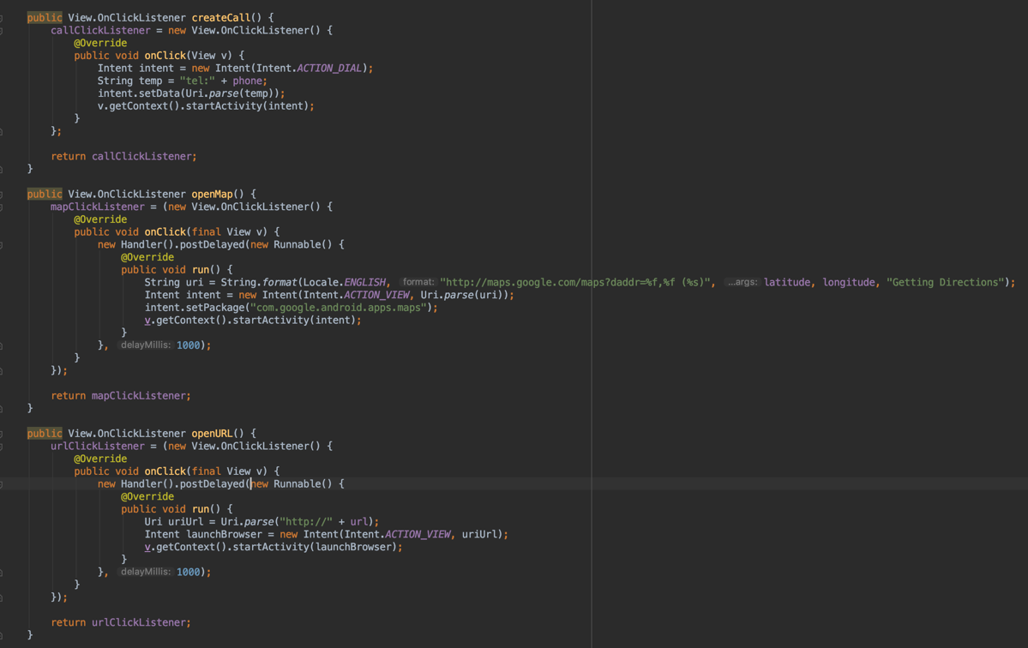

The first method “createCall()” opens the phone application with the phone number. This is done by using the Intent Class. The “ACTION_DIAL” call specifies the action. The number is already in the correct format, and it is “pressed” together with the individual phone numbers on each card. This is how each Card in the CardView will call the correct number. The number format is integer values with no other types of characters.

The “openMap()” method uses a Runnable class, as well as a Handler(). Inside however is once again the Intent class. The code specifies the Google Maps app and passes it the latitude and longitude from the SearchServiceDataObject since it is already inside of the class at that time.

The third method is the “openURL()” method. This uses Handler, Runnable, and Intent as well. The Uri is also a part of the method as well. This is how it parses the website into the correct format. Chrome is the default browser, so it will open natively.

All in all, the different methods that are mentioned above are standard pieces of code that can be reused. The important thing to remember however is that each location is an object, that is passed through this class one at a time. With that unique data being accessed one at a time, it has access to each of those.

With this format of functionality being assigned to buttons, they are pressed together and it has access to the runtime stack. This is a huge issues with the RecyclerViewAdapter(s). It is recommended to add functionality to buttons with this format when possible.

**First Time Login**

When SCHealthPlusMe launches on a device for the first time, it goes into a two screened process that gives the user an idea of what the application offers, as well as the initial setup for the user’s information.

The first thing that comes up is a “SliderAdapter” class and the associated “.xml” files. This functionality is identical to how the Journal works (page 10). It requires two Java Classes named “SliderAdapter.java” and “SliderStart.java” and two xml files named “slide_layout.xml”, which layouts the location of the data that will be displayed, and the “slider_splash.xml” file which will give the background, and buttons that are overlaid.

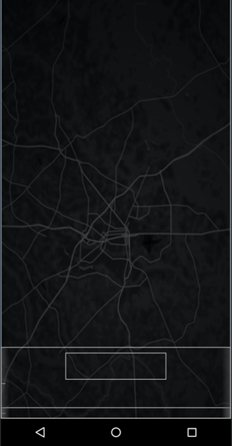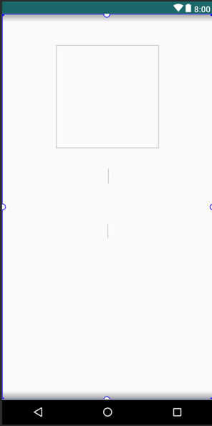

The “SliderAdapter.java” class withholds three arrays that match the three locations that are on the image on the left. The top box is for an image, the middle TextView is for a title, and the bottom TextView is for a description. Below is the three arrays in the “SliderAdapter.java” code:

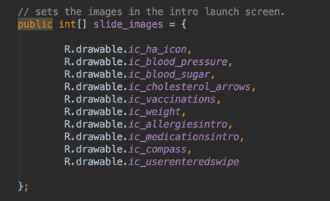

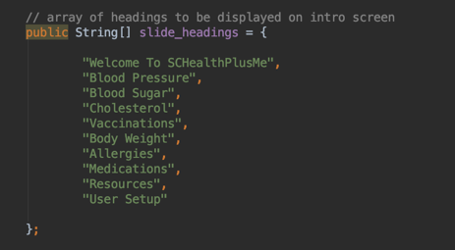

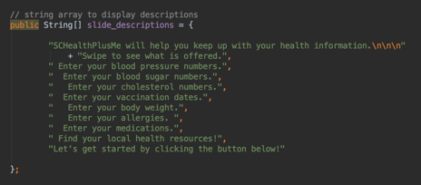

The instantiateItem() method sets the current array position of all three arrays to the Adapter. The code is shown below:

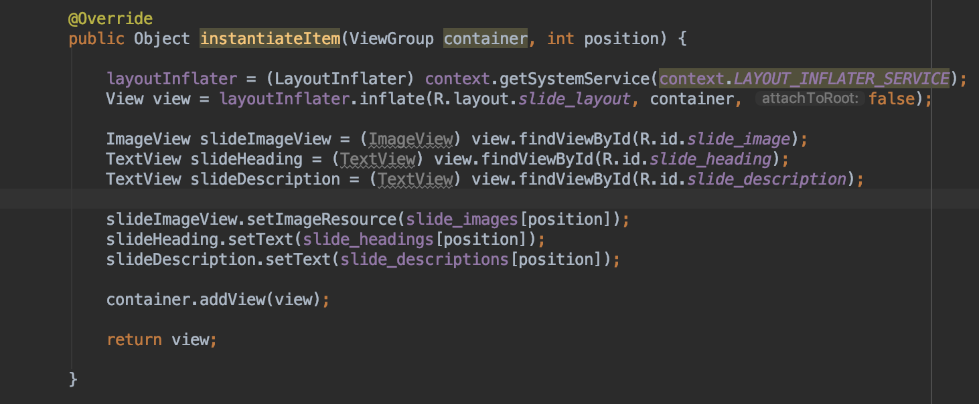

Inside of the “SliderStart.java” class are three important components. The first of which is mNextButton. This Button Object is referenced in the “slider_splash.xml” file and is only displayed on the final page of swiping. This button has the launchFirstTimeLogin() method, which is the user setup. This is accomplished by the following code:

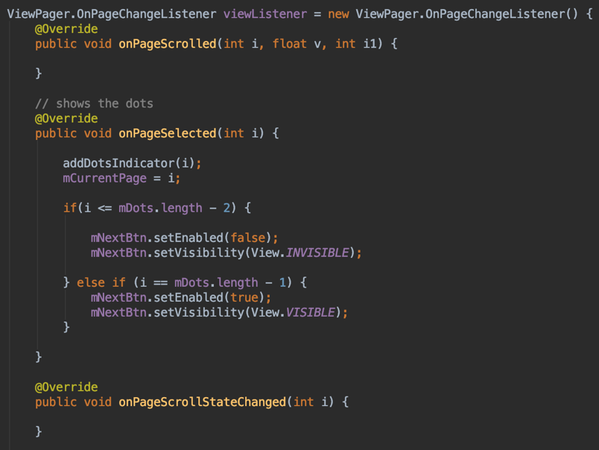

It checks the current position of the array (i) to the length – 1, which will result in the button appearing at the appropriate time.

Once the button is clicked, it takes the user to the User Setup screen. It is important to note that **once the User Setup screen has been reached, it** **can no longer be accessed**.

This class also displays the dots on the bottom of the screen. The code is shown below:

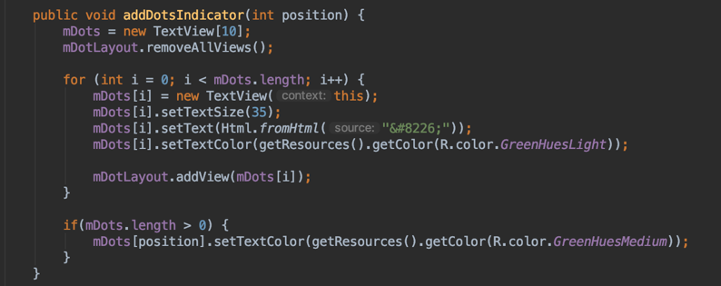

The addDotsIndicator() method takes in the position of the array, and assigns its attributes with the mDots[i] which references the current position of the mDots[] array. The default color of the dots are set above the if-statement, but the current position is set inside of the if-statement, which is the darker color of GreenHue.

This transitions the functionality over to the “FirstTimeLogIn.java” class that handles the user’s input for their name, sex, and date of birth.

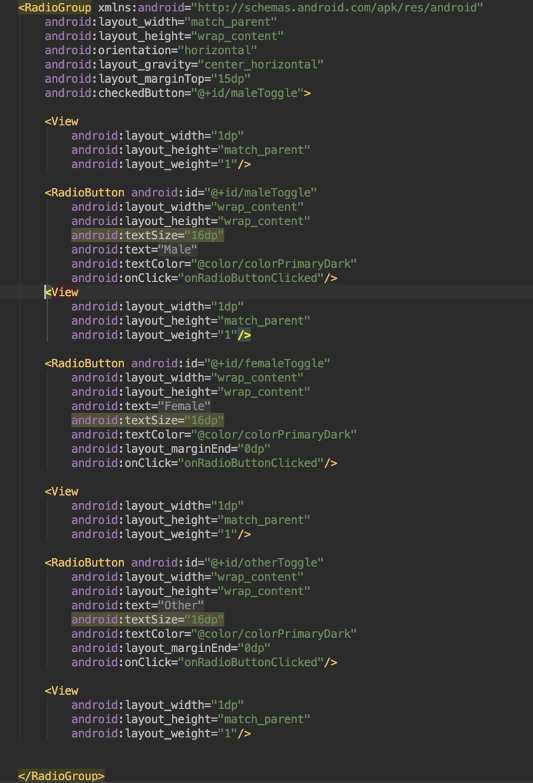Inside of the “FirstTimeLogIn.java” is the code for entering the data. This is similar to the Blood Pressure values that are entered with the “DatabaseHelper.java” class (page 17).

The Radio Buttons that are placed on the screen for the gender are all spaced with equal arrangements thanks to “View” attributes inside of the “activity_first_time_login.xml” file.

These different Views will allow the individual Radio Buttons to be spaced perfectly on all sides to give the option a clean, modernistic look.

The RadioButton(s) themselves must be defined as such, with unique attributes for their appearance.

It is also possible to choose the default toggled button in the RadioGroup attribute.

All of these are placed inside of a “RadioGroup”, which contains all of the formatting for the different options that are within the RadioGroup. Their format, inside of the “.xml file” is shown to the right:

The final portion of the FirstTimeLogIn.java is crucial. It is how the application determines whether the user has created a profile or not.

This is determined in the MainActivity.java class, which is the main class of the entire application. It is the first one that is run, and it makes the choice to display the Sliding Intro Screen, and corresponding User Setup screen.

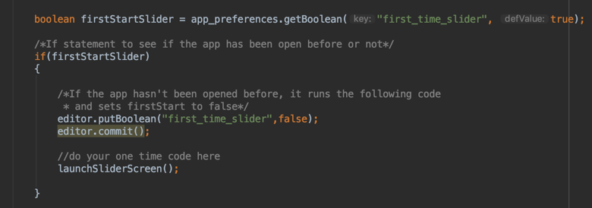The following code determines whether the Slider Launch Screen has been seen or not. This is a built-in method into Java specifically for Android and will allow the application to know, as shown below:

If the screen has been seen, then it will not launch it, but if it has not been seen, then it will call the method to launch the screen.

The final check, and most important, is whether a user was inputted into the database. This is done via the method that is shown below:

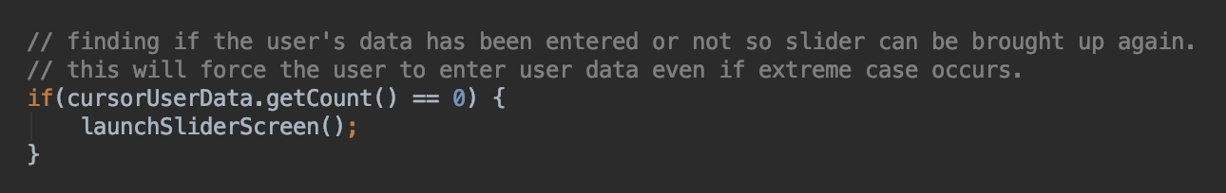

This will be a final check incase the user quit the application while the setup process was ongoing. It is important for the user to not have a way into the application without a user setup, so this portion of the app is double stacked in precautions.

Once a user has entered information, they may have made a mistake. This is where the Edit Profile Screen is useful.

The layout of the screen, and the “EditUserProfile.java” file is exactly the same as the FirstTimeLogIn counterparts. The only major difference comes in the “DatabaseHelper.java” class, and the method that is called inside of the “EditUserProfile.java” class.

This differing method is no longer an insertion, but an update to an existing row. This is done via the updateUserData() method. It is shown below:

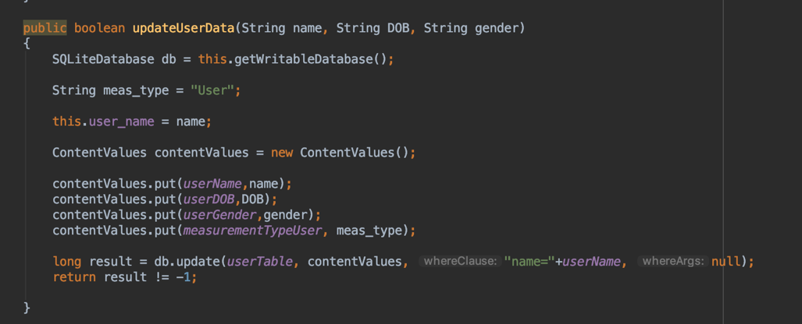

Here the “db.update” method call sets up a change instead of an addition. It accesses the userTable, grabs the values being inserted, then it adds a where clause for where the name is equal to the user’s name. This will overwrite the current user’s name with the new one, as well as the other information.

Modification can be achieved by making a button, attaching the update method to it, and pass it the unique value to be updated. Inside of the screen’s prompt, pass its unique identifier to the update method and give the user the input to change the values, similar to the Edit Profile screen.

This is the only modification in SCHealthPlusMe as of version 1.0.1 on the Google Play Store. The other values in the Health Journal can only be deleted as shown on **page 21.**

**Conclusion**

SCHealthPlusMe is a uniquely built Android application that will give users the ability to take control of their health. The functionality of the application is described by the previous sections. The Table of Contents should be sufficient in finding a particular section, but the overall direction of these document is to be read **in order**. It builds upon each section, but it also references other portions of the documentation appropriately.

SCHealthPlusMe meets all Google Play requirements as they tighten up on their rules on application submissions. The new icon is in place, and it has a privacy policy linked inside of the application, as well as on the Play Store page.

The [SCHealthPlusMe Clinic Location Web Manager](https://fmu-scra.github.io/SCHealthPlusMeClinicManager) is now live. The documentation for its usage will be on the GitHub’s README. It is hosted using GitHub Pages, and with its uniqueness, it will remain discrete and out of the wrong hands. It is handled in each situation possible, and completely safe as long as the person using it does not want to damage the database. It deletes data **ONLY** by its unique hex value.

Given the state of SCHealthPlusMe, an iOS version of the application will be developed differently, but the implementation should follow the sections that are outlined in this document. The Firebase database is to be referenced, as well as the table ER model for the local SQLite database is to be replicated.

The remainder of the application is simply a translation from “Java”, “.xml”, and a “gradle.build”, to Swift. Xcode is also different in a lot of ways from Android Studio.

As of writing this conclusion, Apple has recently unveiled their next generation of Swift. A part of that update is “SwiftUI.” SwiftUI is a simple framework of sorts that Apple made themselves that will dramatically reduce the time that a developer has to worry about the UI of their application. It will automatically be built for iOS, iPadOS, and macOS. This will be an amazing time saver for SCHealthPlusMe’s next stage of development.

The design of the UI on the iOS version may be slightly more modernistic, but I would encourage it. I love the design of the Android version, but the best thing about Software Engineering is to always improve and change things for the better. Find the best design for the implementation and go from there.

To whomever reads this documentation, I hope it is helpful and describes the different scenarios thoroughly. Each subset of the application is represented, so it should be replicable. This document summarizes a year’s worth of solely focused work. Don’t let it overwhelm you on a single read of trying to understand.

Thank you for reading this document and I congratulate you on getting to the end.